**Dev-Ops Continue Integration -Continue Deployment Project`**

**Project scope:   
Integrate GIT-Jenkins-Docker for CI-CD Process.   
The source code is Load, Integrate, Test and Stored in Private repository.**

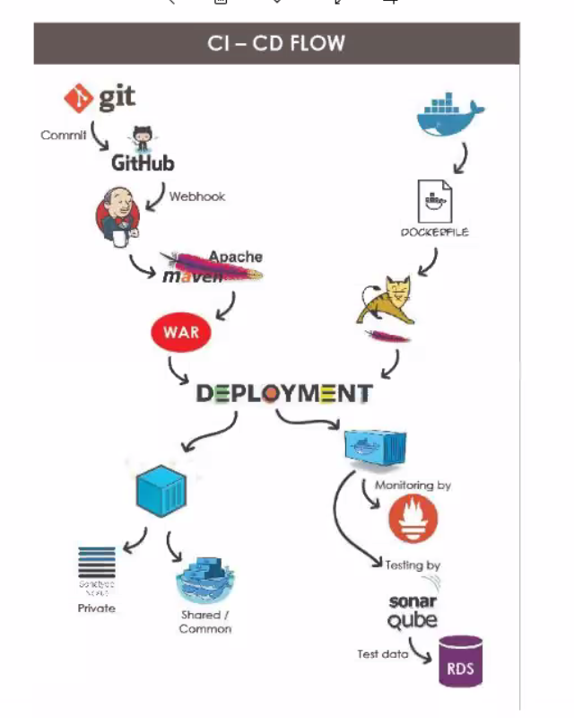

**Flow of Continue Integration -Continue Deployment**

1. Developer ***Commits*** the the code to **GITHUB**

2.The code will trigger / ***web hook*** to **Jenkins**

3. **Jenkins** Trigger to **Apache Maven**.

4.Maven the Build tool build the source code to **WAR** formatted file

5. The **WAR** file stored to the **Sonar Qube** (code quality control tool), test the quality of the source code built in WAR file.

**Parallel Process**

the **Docker** stores / push the **docker image** to install into the **Tomcat server** and move it into.

6. The **war** file will be unzipped / converted and moved into **docker container.**

7.The docker container monitored by the monitoring tool- **Prometheus**

8.the **Sonar Qube** (code quality control tool), store the data in to **AWS-RDS / MySQL** as data format.

9.The docker image will move to **Private repository** - **Sonar Nexus**

**Devops - tools used in the Project**

1. GIT / GitHub - The version control tool

2. Jenkins -Integration Tool

3. Apache Maven - Code Build Tool

4. Apache Tomcat - Application Server / Web Server

5. Sonar Qube - code quality control tool

6. Docker / Docker Hub - Docker Container

7. Prometheus - Monitoring tool

8. Sonar Nexus - Private repository

9.AWS Cloud - EC2 / Linux Instances to **Jenkins, SonarQube, Prometheus,Nexus**.

& RDS services - Database.

Process **1. Integration Part**

1.Create 3 Nos of Linux Machines – with 4GB Ram and Java  
  
 1. **Jenkins** (Git, Docker,Jenkins , Java, Apache Maven)

2**. Sonar Qube** (Java, MySQL, SonarQube)

3**. Sonar Nexus** (Promethesis, Sonar Nexus).

**Project Process.**

1. **Create Linux Machine – 4GB Ram, T2.Micro Tag as Jenkins**

In SSH –(Putty) – Login as Root user

Install GIT

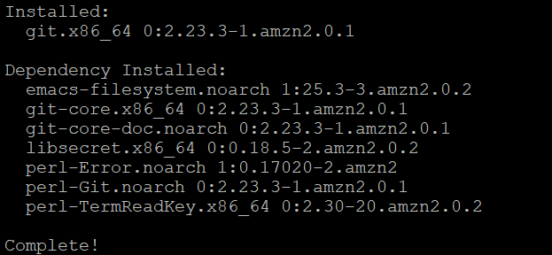

1. Install Docker.  
   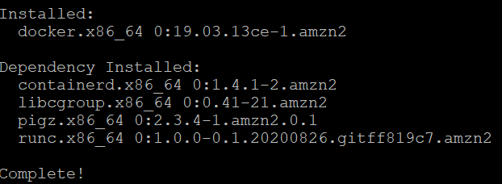

3.**Download & Jenkins install**https://wiki.jenkins.io/display/JENKINS//Installing+Jenkins+on+Red+Hat+distributions

# sudo wget -O /etc/yum.repos.d/jenkins.repo http://pkg.jenkins.io/redhat/jenkins.repo

# sudo rpm --import http://pkg.jenkins.io/redhat/jenkins.io.key

# sudo yum install Jenkin

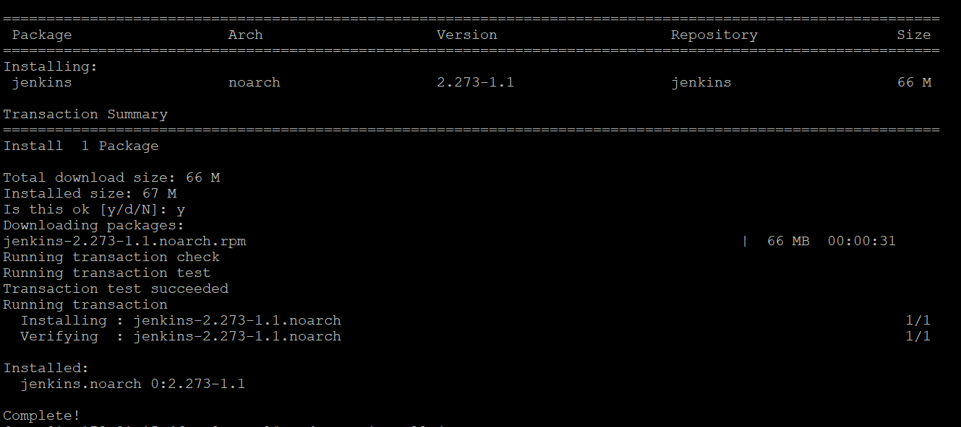

**4. Install Java**

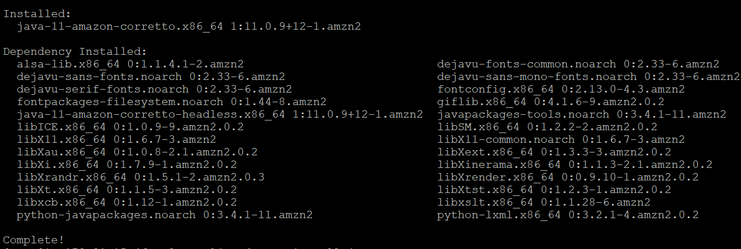

# service jenkins start

**5. Open Jenkins in browser**

xxx.xxx.xxx.xxx : 8080 – (the default port for Jenkins is **8080)**

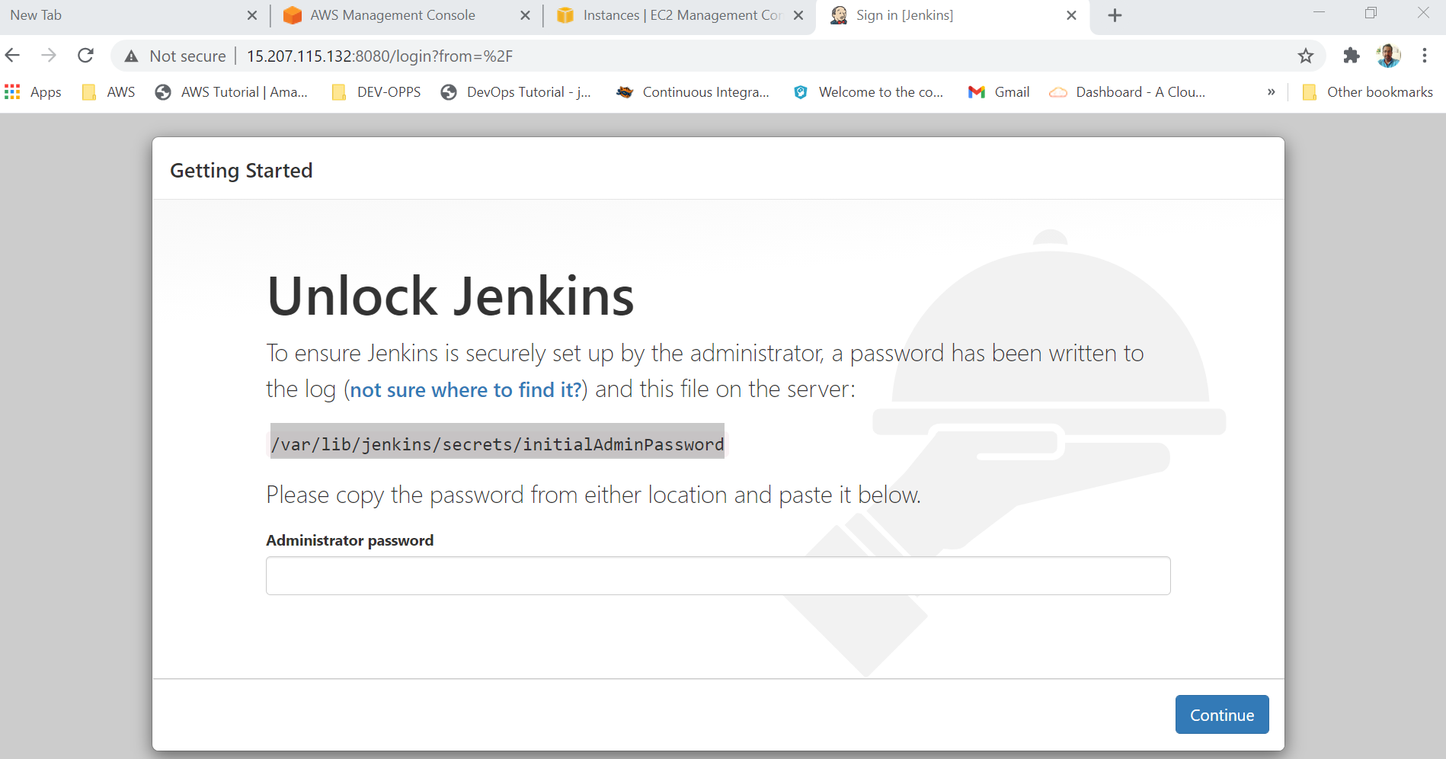

**Copy the unlock key and paste in Jenkins instance**

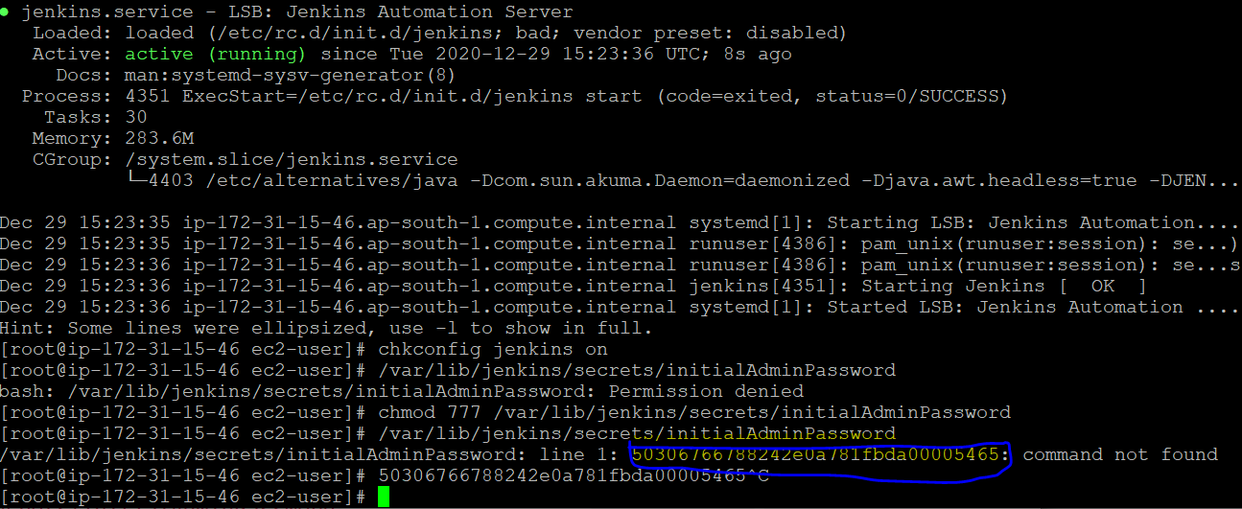

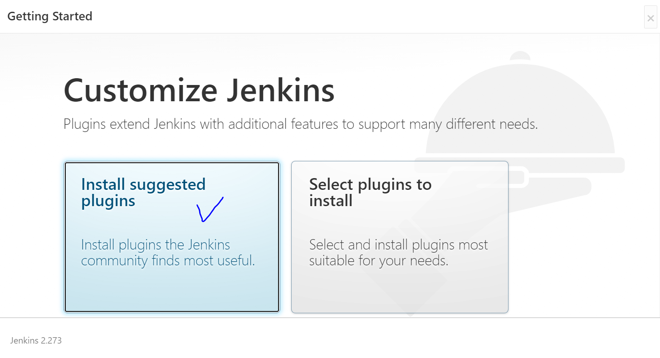

**Plugins Installed**

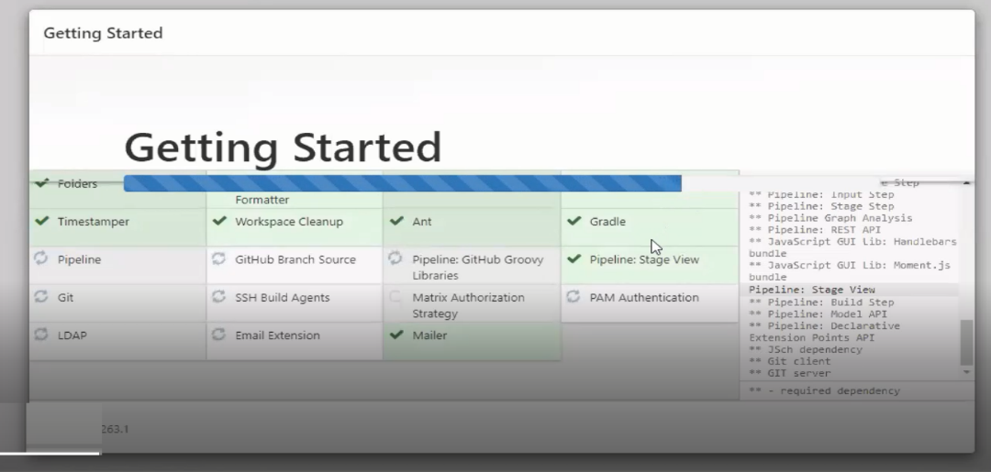

**6.Download & install Maven for apache**

* <http://mirrors.estointernet.in/apache/maven/maven-3>
* <http://mirrors.estointernet.in/apache/maven/maven-3/3.6.3/binaries/>
* apache-maven-3.6.3-bin.tar.gz - copy the link address

**#6. 1. Maven bianaries download from the official maven website**

**## Maven should not be installed in /root path.**

**Here we choose /opt/** under apache-maven-3.6.3

downloaded as tar.gz format

wget [http:/mirrors.estointernet.in/apache/maven/maven-3/3.6.3/binaries/apache-maven-3.6.3-bin.tar.gz](http://mirrors.estointernet.in/apache/maven/maven-3/3.6.3/binaries/apache-maven-3.6.3-bin.tar.gz)

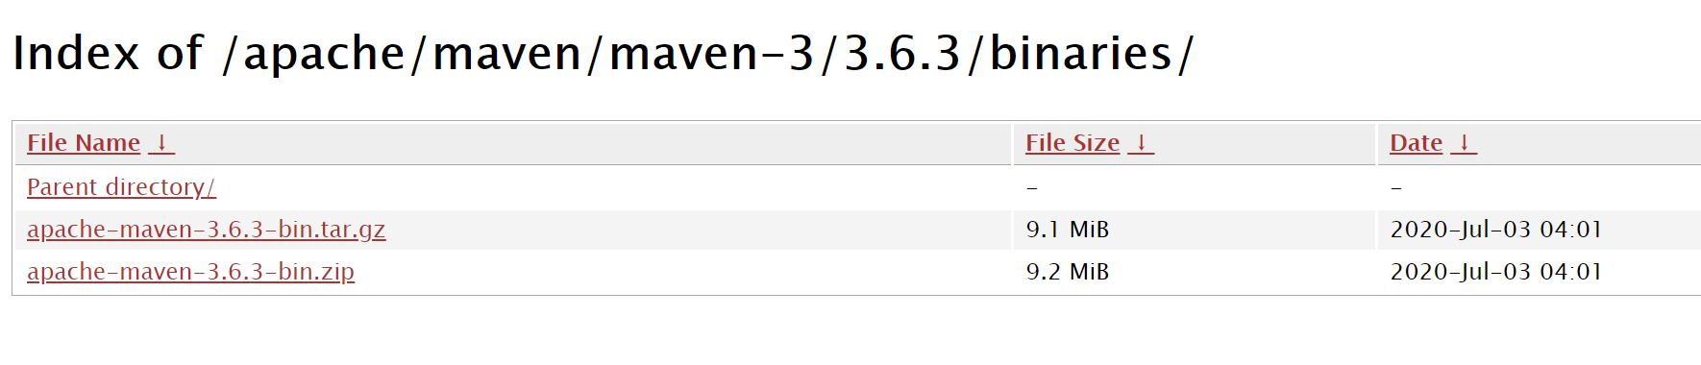

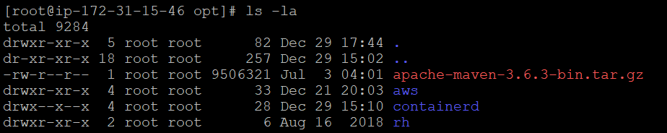

**#6.2. to unzip the apache-maven-3.6.3-bin.tar.gz**

**# tar -zxvf apache-maven-3.6.3-bin.tar.gz**

[root@ip-172-31-15-46 opt]# tar -zxvf apache-maven-3.6.3-bin.tar.gz

**#6.3. Install the Maven integration plugins in the Jenkins**

==-=-=-=-=--=-=-=-=-=-==-===-=-=-=-=-=-==-=-=-=-=-=-=-=-=-=-=-=-=-=-=-=-=-=-=-=-



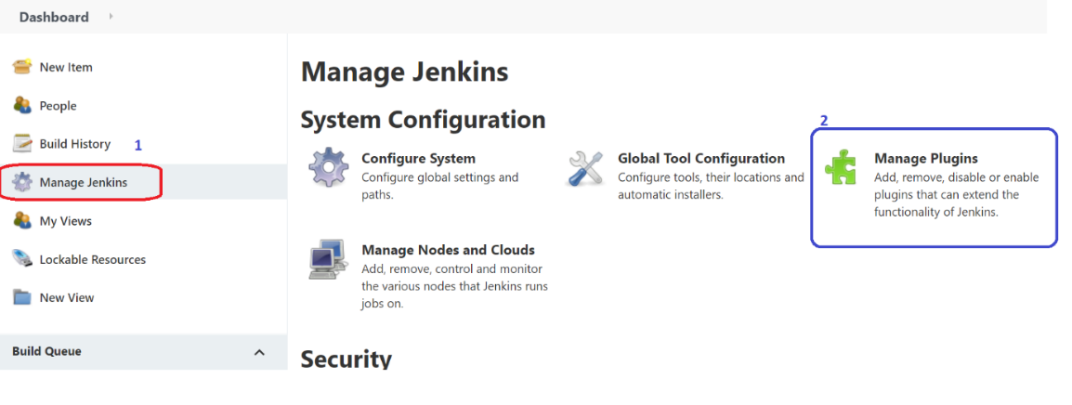

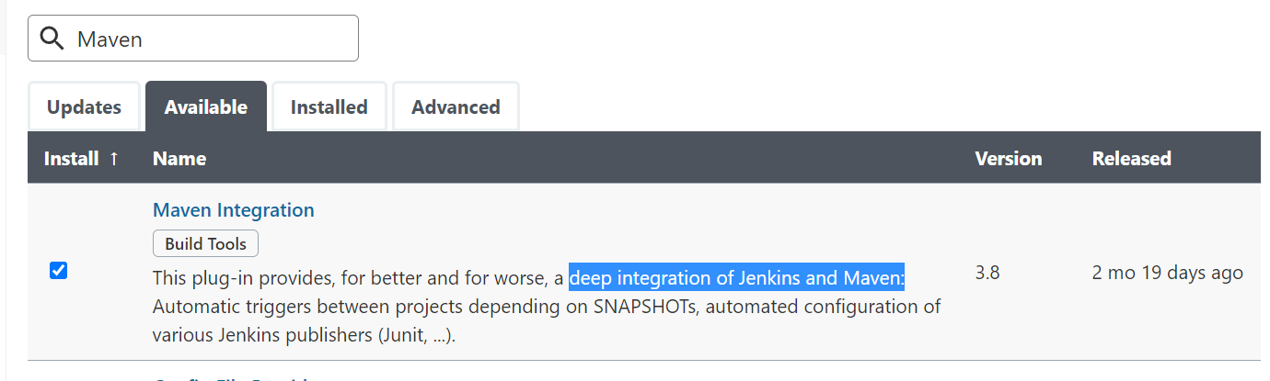

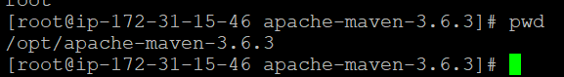

**#6.4. In the Global tool configuration 🡪 search and add the   
name and application home path.**

Name : from Jenkins config file

Homepath : the Jenkins Linux instance path

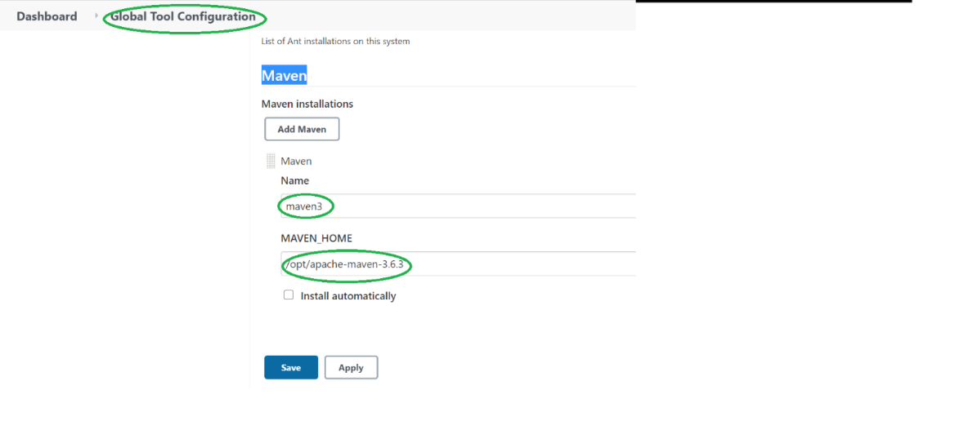

**New Item🡪**

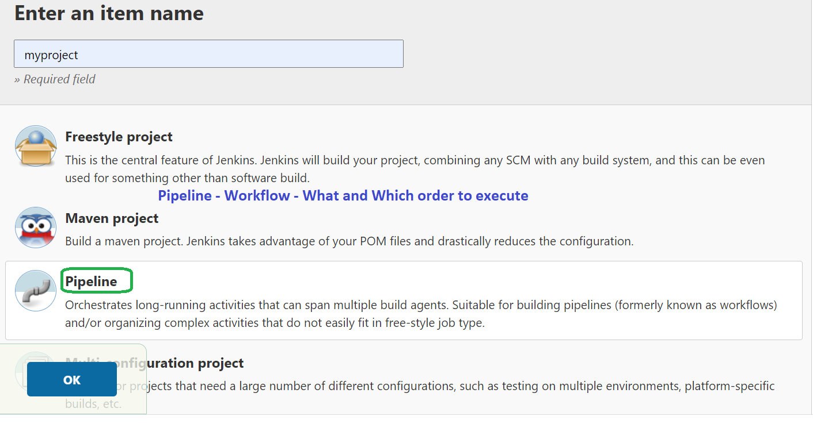

*Pipe line :* Continuous Integration and Execution

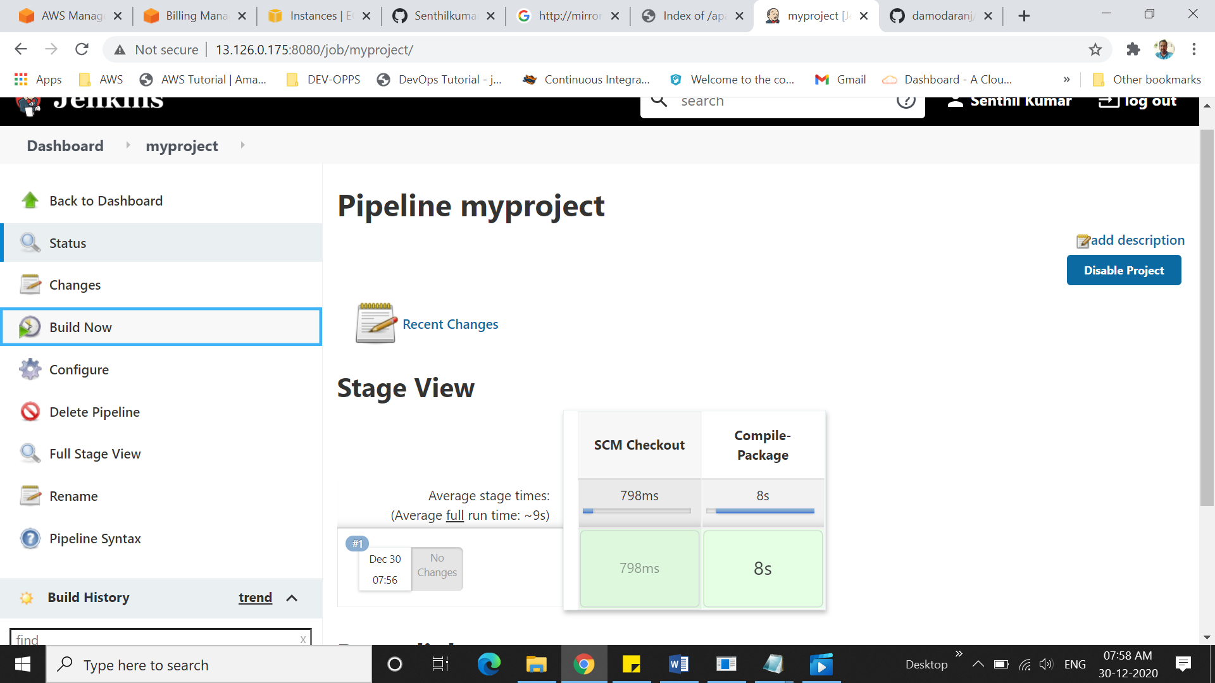

**Build Success.**

**The output file is stored in /var/lib/jenkins/workspace/myproject/target/**

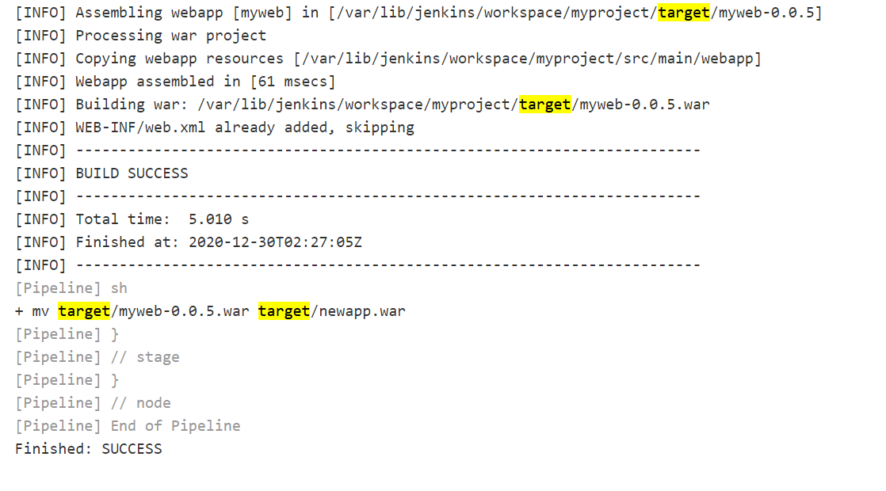

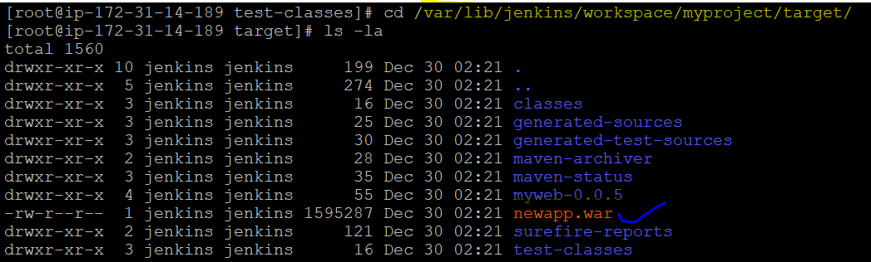

**# 6.6 Build Docker in Jenkins :**

**Create new docker image in Docker hub**

**Credentials to pass password to docker ….**

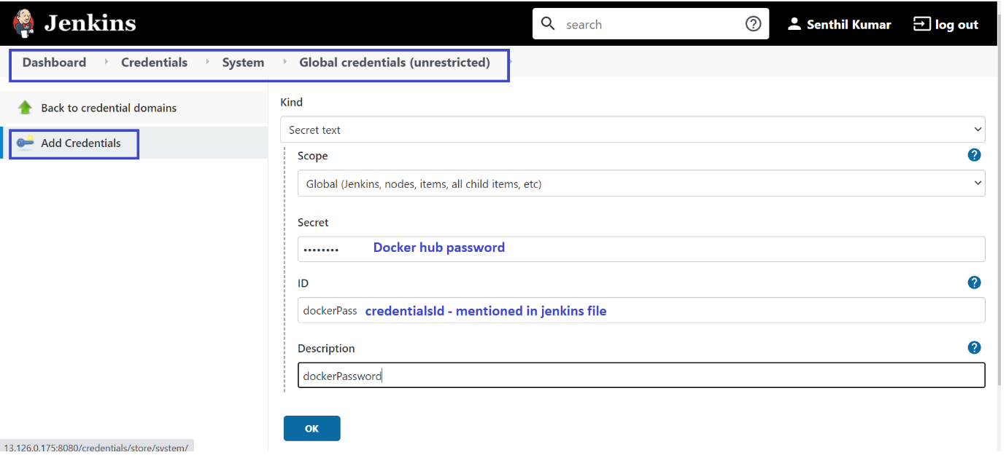

**Secret : Docker hubs password**

**Credentials Id - mentioned in jenkins file (must to keep same in both place)**

**Add the create docker image script from jenkins file to pipeline path**

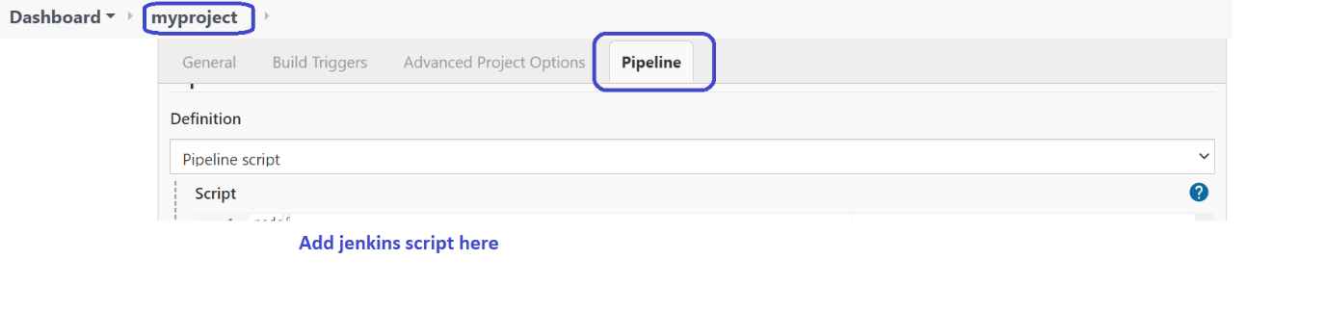

Pipeline shows error

+ docker build -t sendocx/myweb:0.0.2 .

Got permission denied while trying to connect to the Docker daemon socket at unix:///var/run/docker.sock: Post http://%2Fvar%2Frun%2Fdocker.sock/v1.40/build?buildargs=%7B%7D&cachefrom=%5B%5D&cgroupparent=&cpuperiod=0&cpuquota=0&cpusetcpus=&cpusetmems=&cpushares=0&dockerfile=Dockerfile&labels=%7B%7D&memory=0&memswap=0&networkmode=default&rm=1&session=c3uiuzg3ll704fd05i3jrh0fb&shmsize=0&t=sendocx%2Fmyweb%3A0.0.2&target=&ulimits=null&version=1: **dial unix /var/run/docker.sock: connect: permission denied**

[Pipeline] }

[Pipeline] // stage

[Pipeline] }

[Pipeline] // node

[Pipeline] End of Pipeline

ERROR: script returned exit code 1

Finished: FAILURE

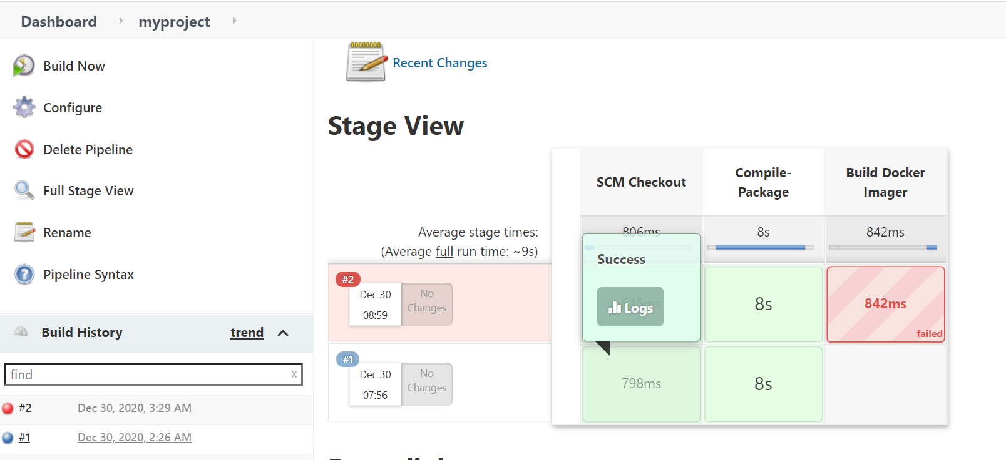

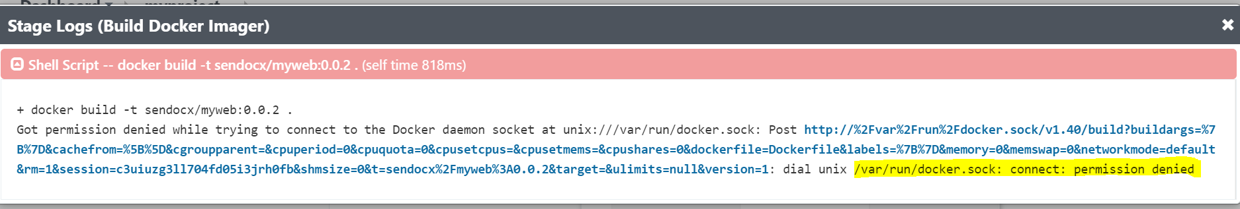

# chmod 777 /var/run/docker.sock

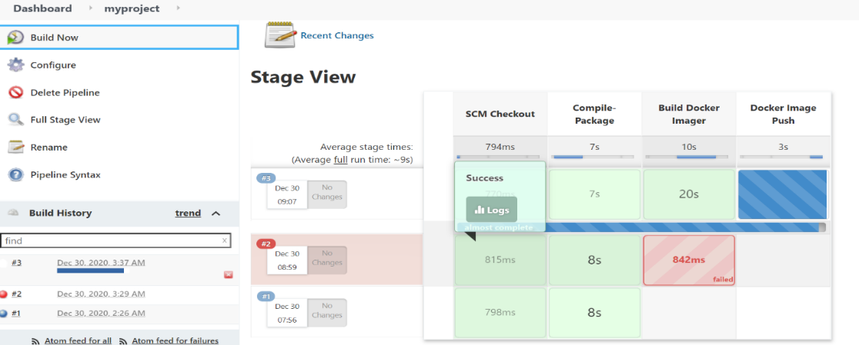

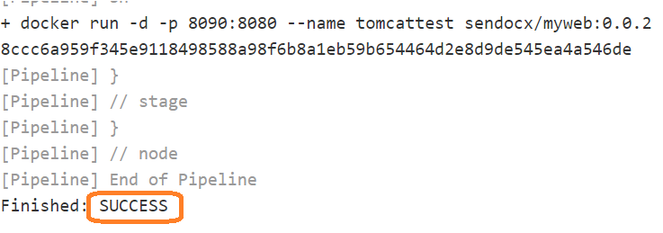

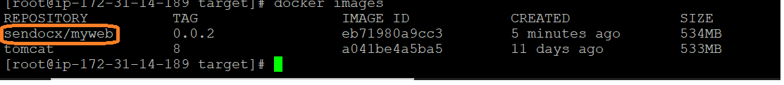

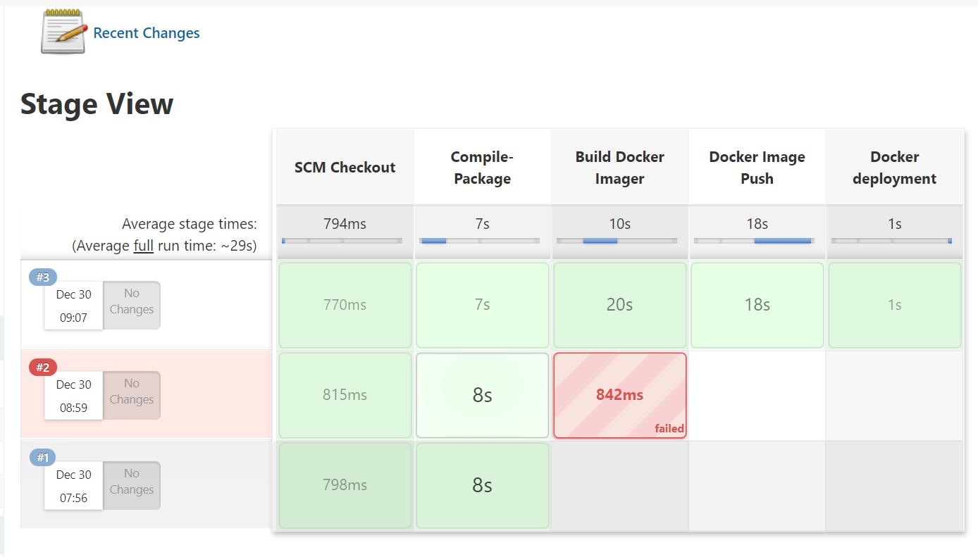

The code build WAR file is now run inside the **Tomcat** port :8090



**# 6.7 – Execute the App.**

**Select Public IP of Jenkins Linux instance**

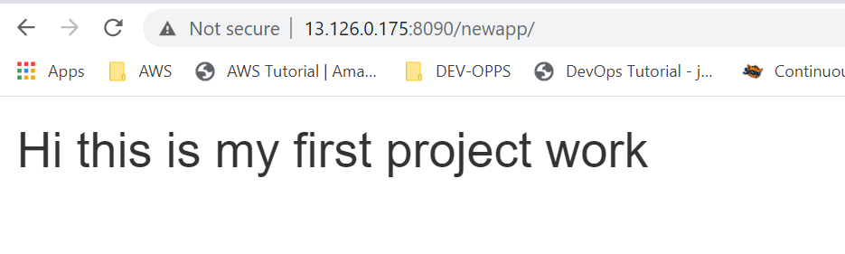**2.Deployment Part**

**1.SonarQube**

**Pre Requisites:**

1. 4GB Ram Machine
2. Install Java
3. Need Database-(SonarQube stores all test data into the database)
4. Need create user, groups, & Give permissions to access the database

**# 1. Create Database – We use here Amazon RDS- MySQL**

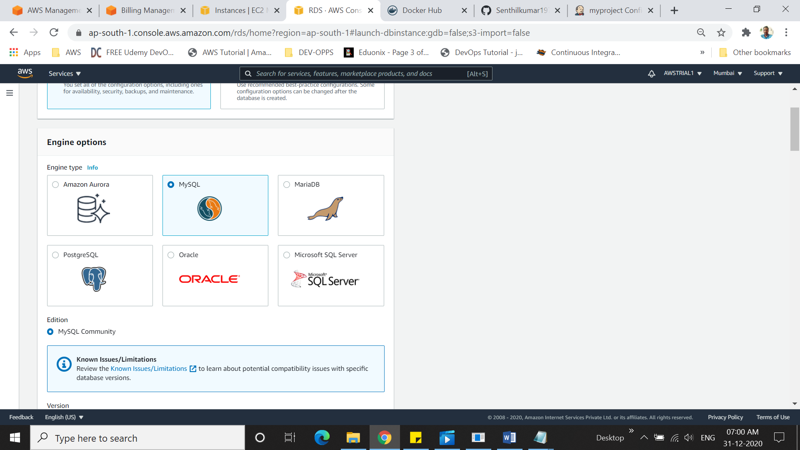

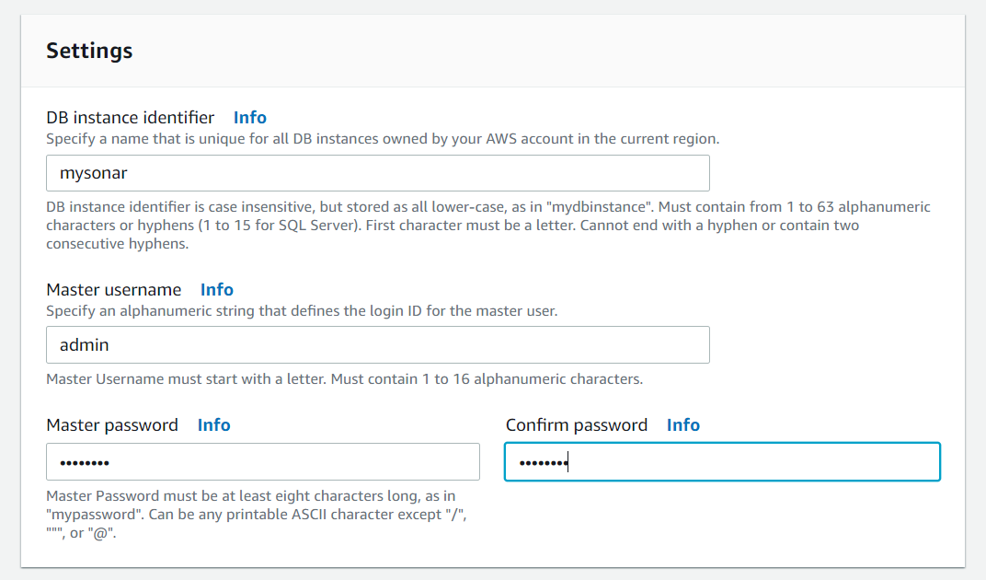

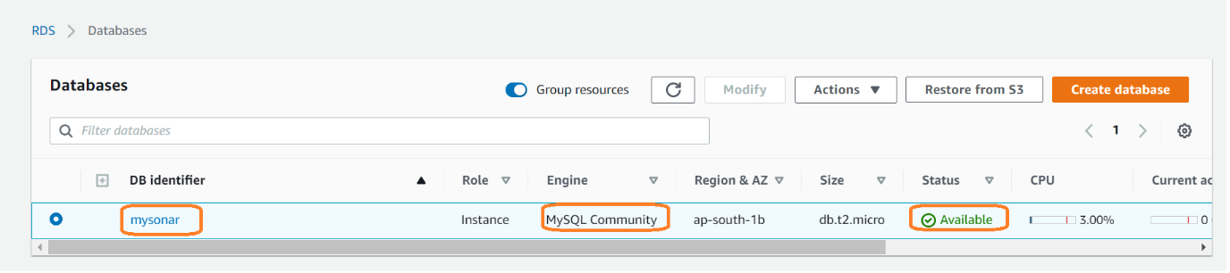

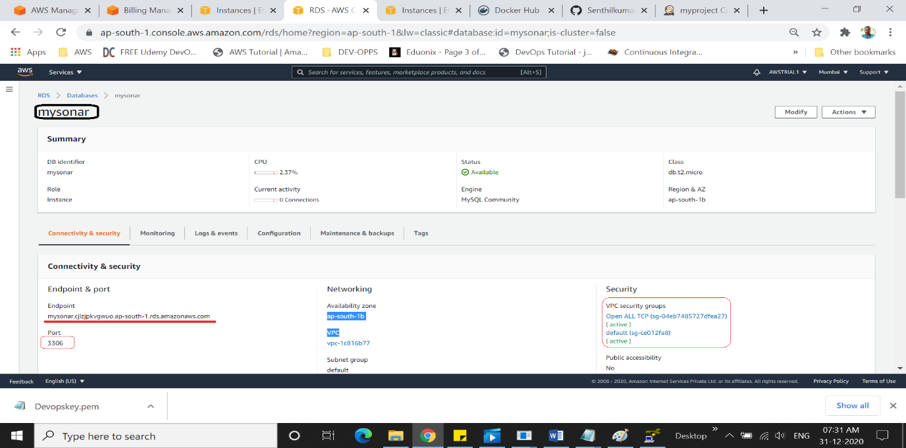

Database Created..

**#2. SonarQube Instance Creation**

1. Amazon Linux

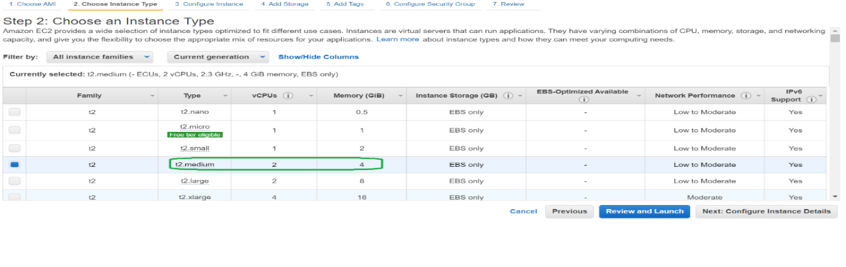

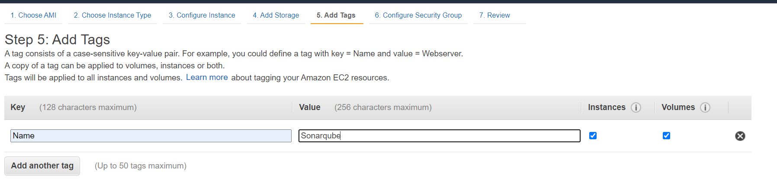

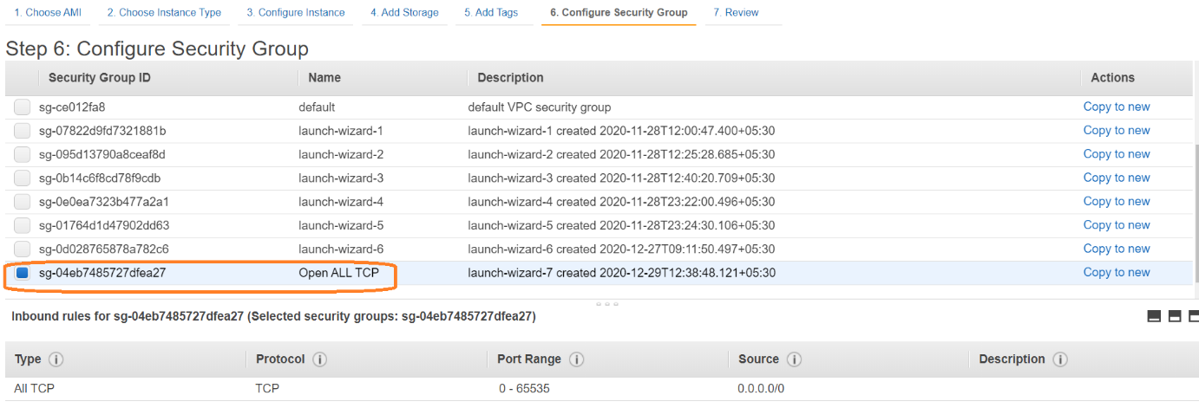

**# 3. Installing JAVA**

# sudo yum install java-1.8.0

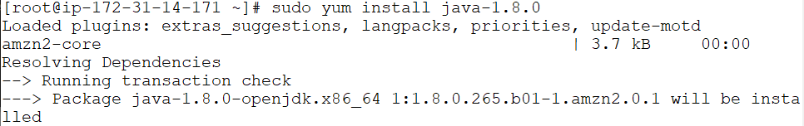

**# 4.Database Install**

MYSQL install as RDS in SonarQube

#yum install mysql -y

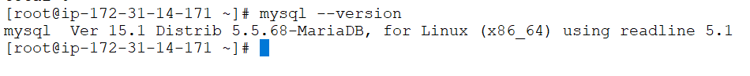

***To connect Amazon RDS with MySQL.***

# mysql -h mysonar.cjizjpkvgwuo.ap-south-1.rds.amazonaws.com -P 3306 -u admin -p

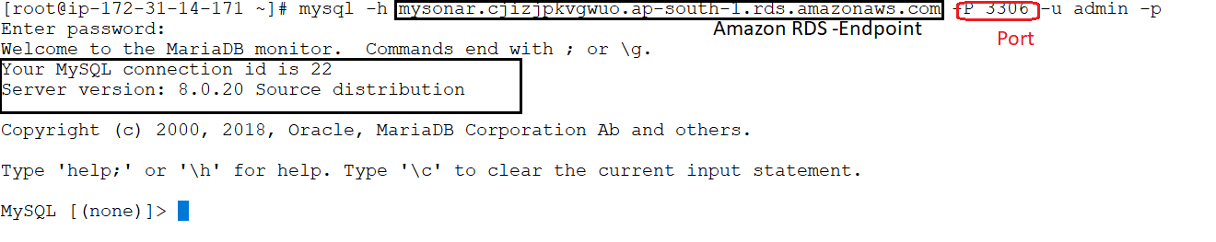

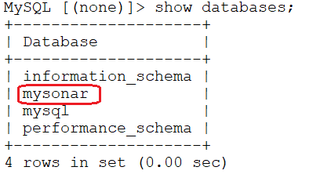

#4. Need create user, groups, & Give permissions to access the database 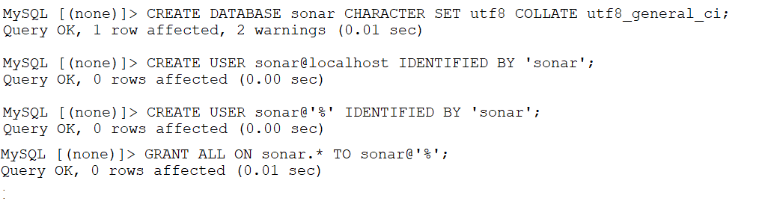

5.Installing SonarQube :

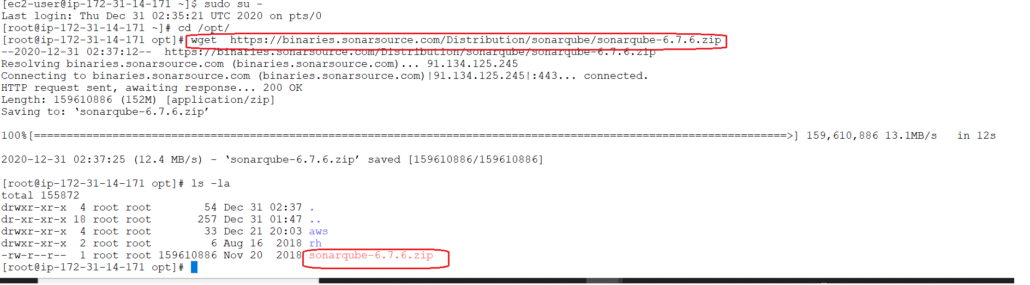

#unzip sonarqube-6.7.6.zip

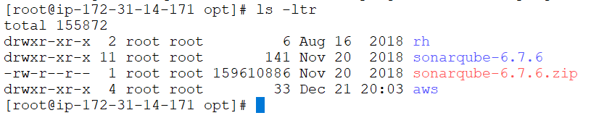

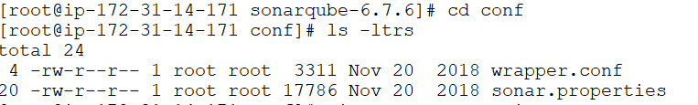

Edit sonar.properties

sonar.jdbc.username=admin  
sonar.jdbc.password=admin123

sonar.jdbc.url=jdbc:mysql:  
//mysonar.cjizjpkvgwuo.ap-south-1.rds.amazonaws.com:3306 (**Amazon-RDS-Database Endpoint)**  
/sonar?useUnicode=true&characterEncoding=utf8&rewriteBatchedStatements=true&useConfigs=maxPerformance&useSSL=false

# By default, ports will be used on all IP addresses associated with the server.

**sonar.web.host=0.0.0.0**

# Web context. When set, it must start with forward slash (for example /sonarqube).

# The default value is root context (empty value).

**sonar.web.context=/sonar**

# TCP port for incoming HTTP connections. Default value is 9000.

**sonar.web.port=9000**

Edit wrapper.conf

usr/lib/jvm/java-1.8.0-openjdk-1.8.0.265.b01-1.amzn2.0.1.x86_64/jre/bin

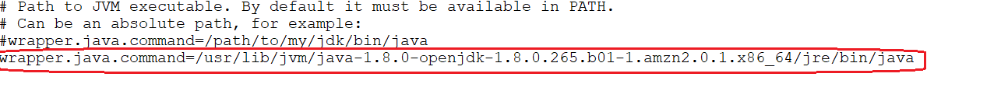

SonarQube Shouldn’t execute as root user - should be non-root user only

# chown -R ec2-user:ec2-user /opt/sonarqube-6.7.6/ - Change ownership to user

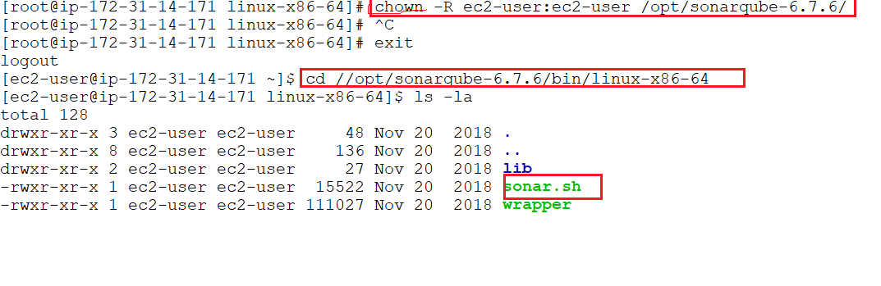

Now start sonarch.sh

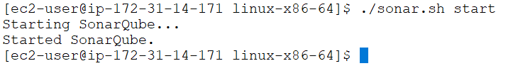

**Access SonarQube Machine**

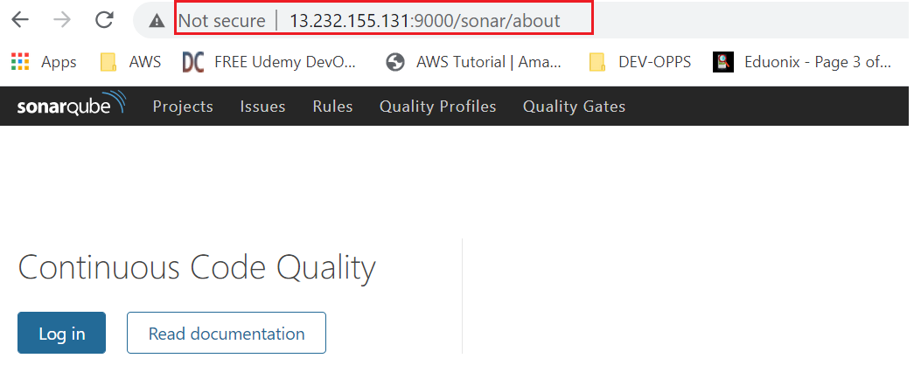

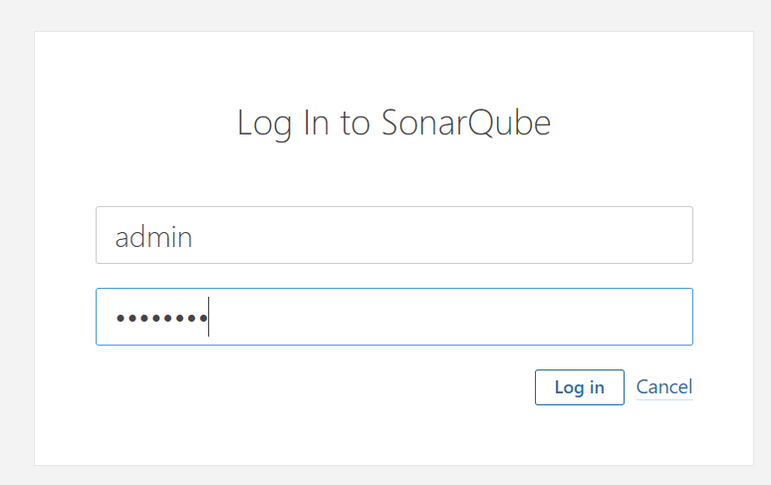

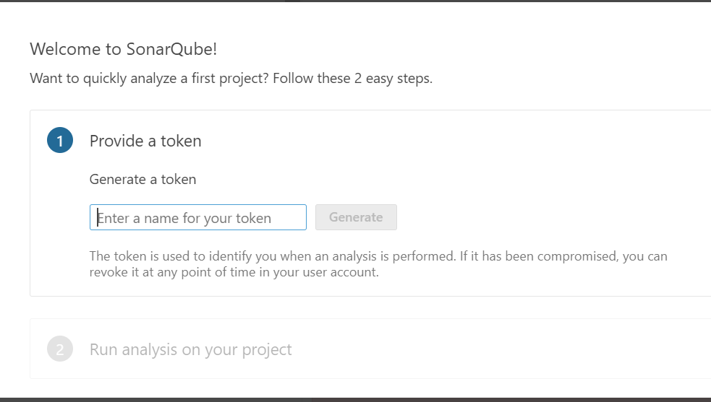

Sonarqube main

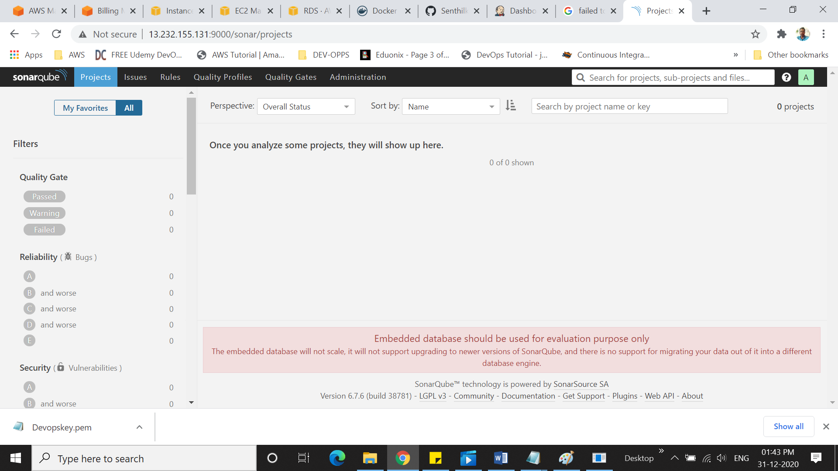

**Integrate SonarQube and Jenkins**

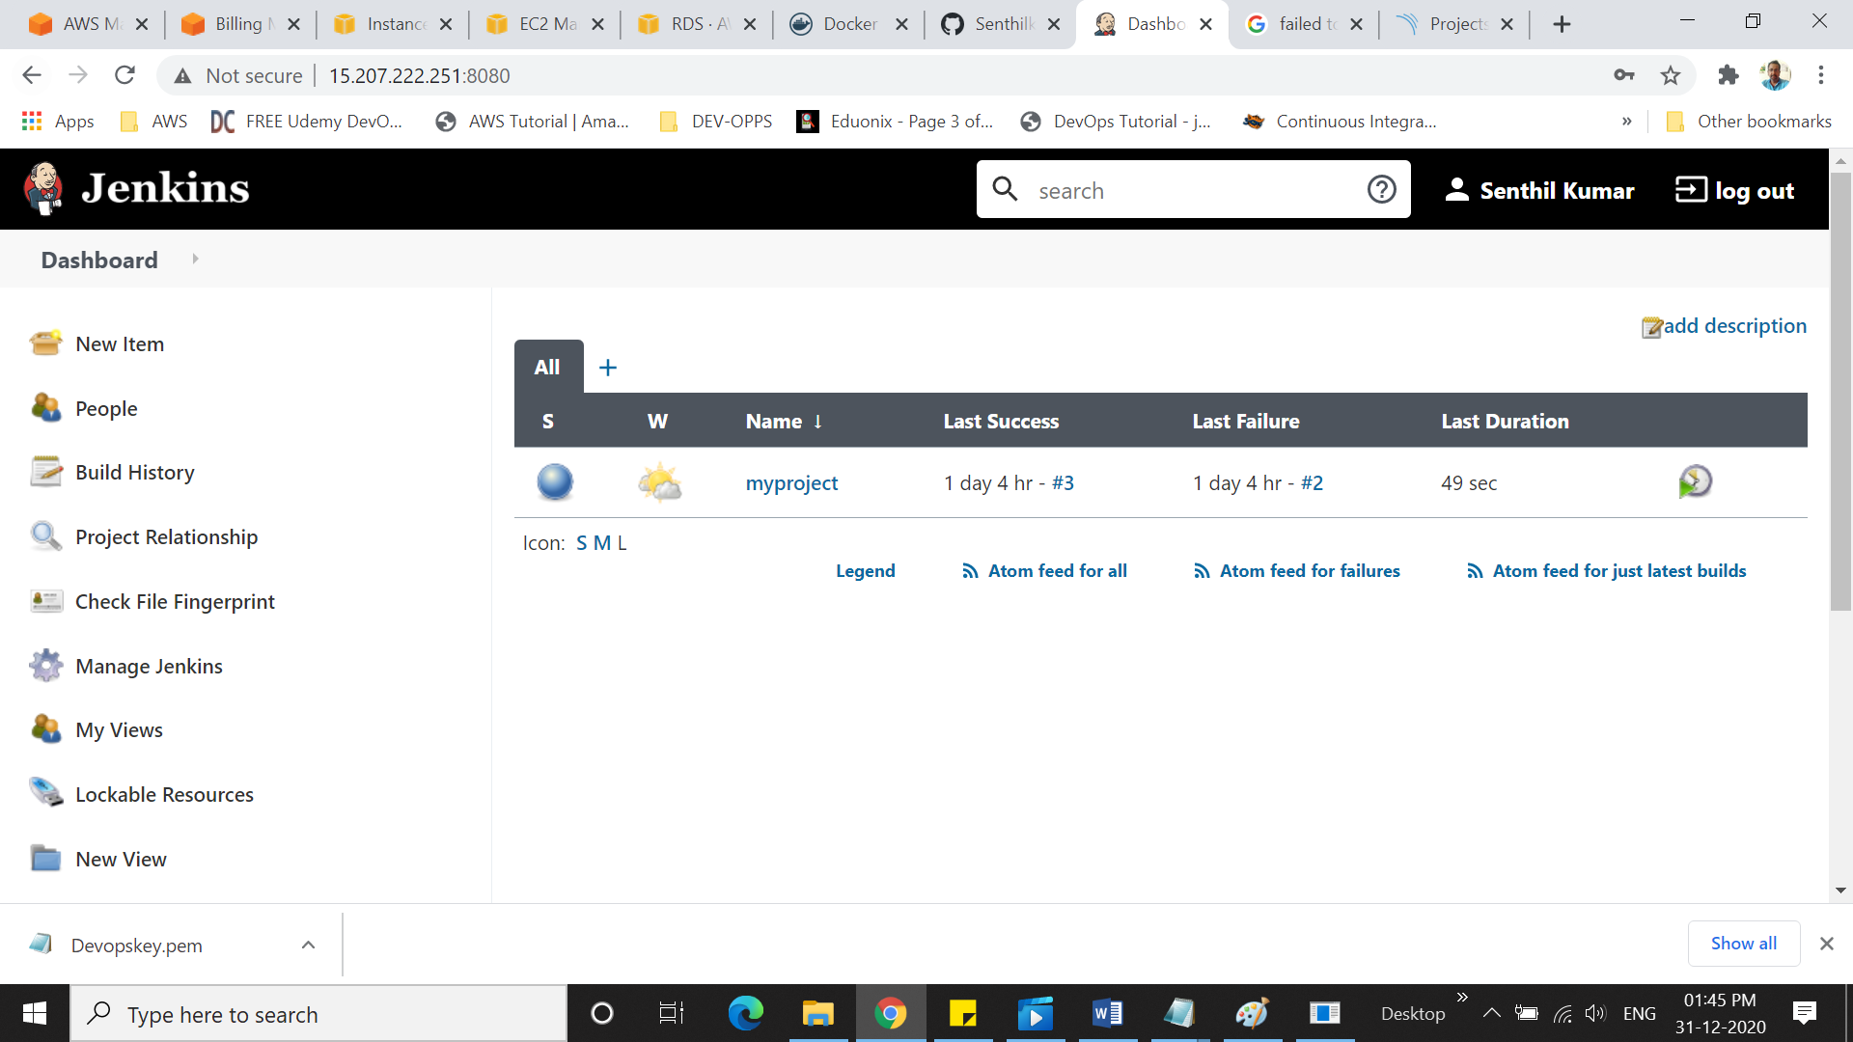

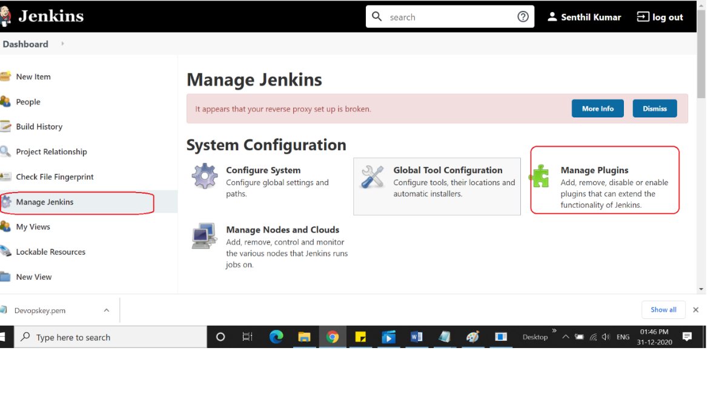

Select available and search sonar

**Select SonarQube scanner for Jenkins**

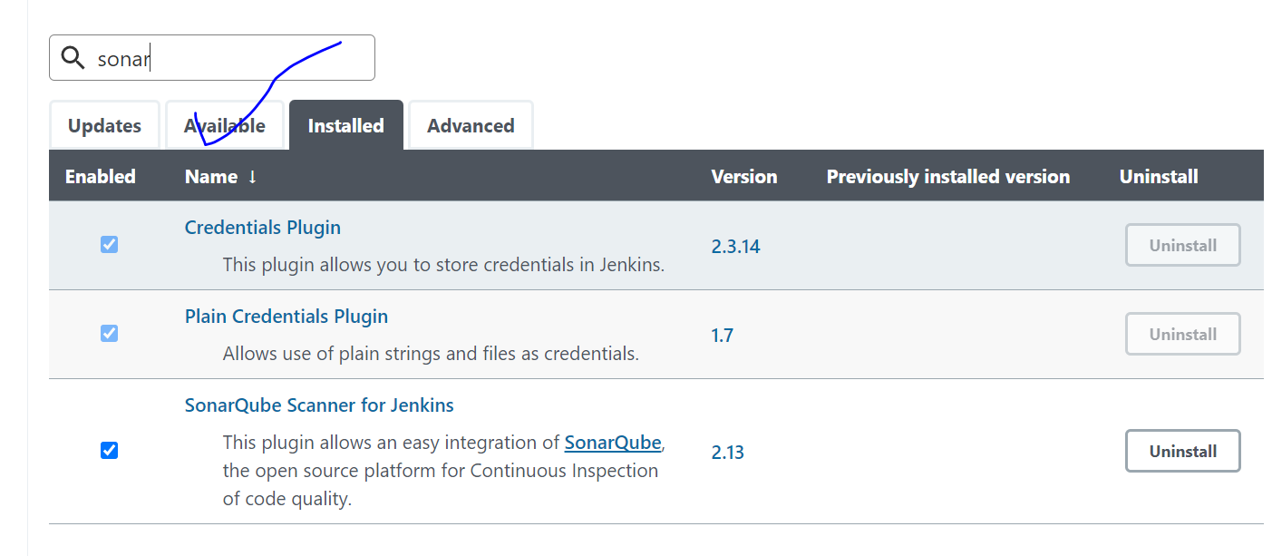

Applying SonarQube token to Jenkins for integrate the two tools.

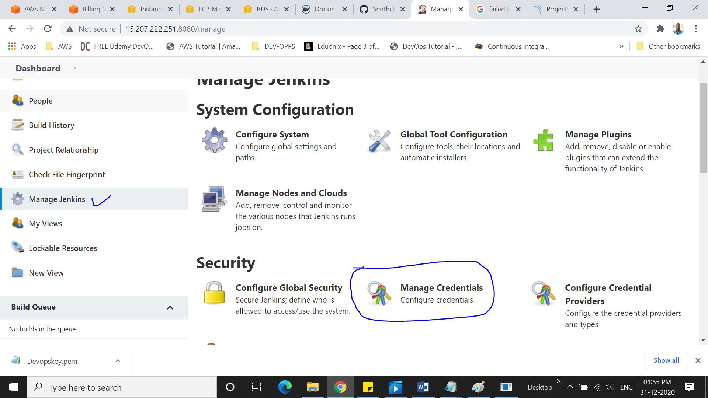

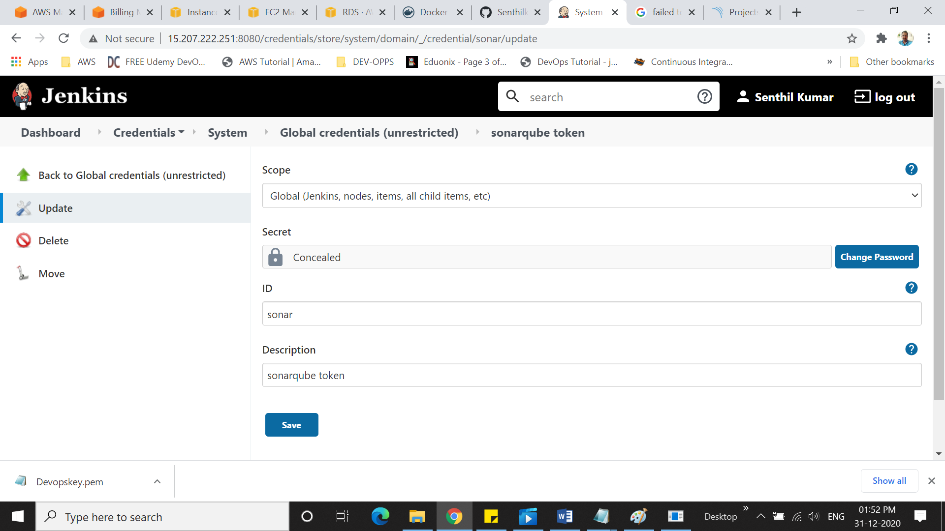

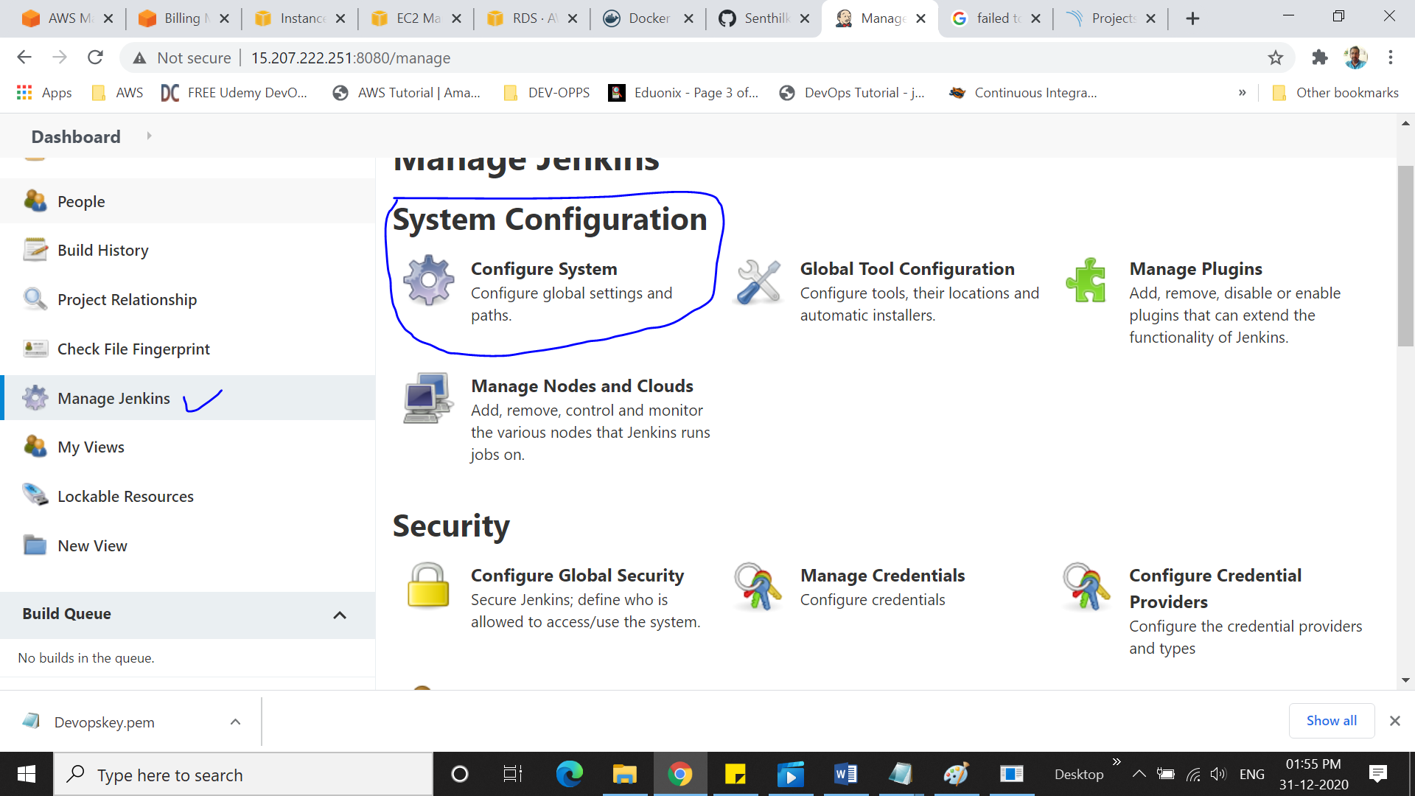

**Configure SonarQube Token with Jenkins**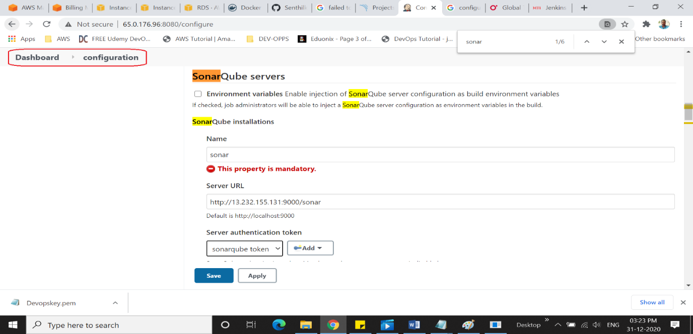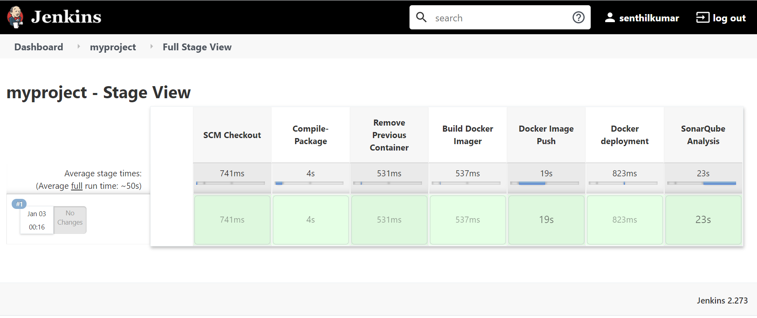

SonarQube Analysis Report

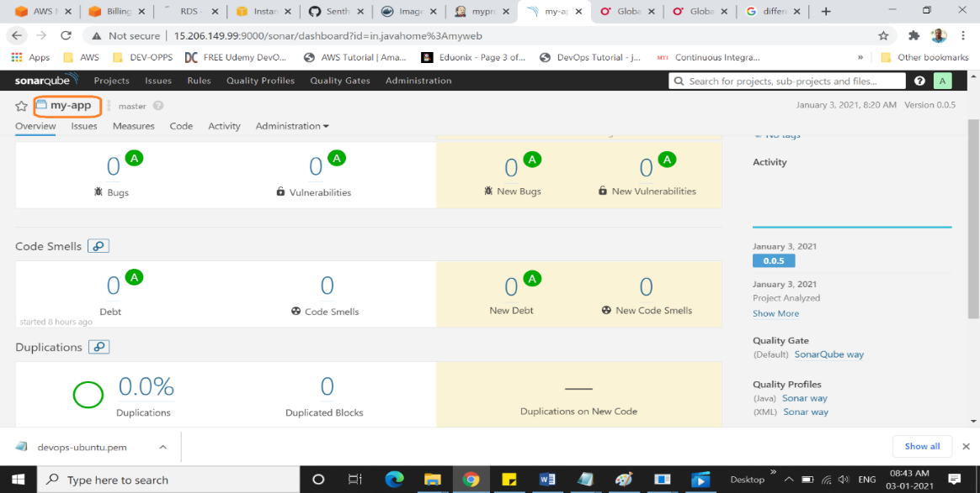

**6.Sonatype Nexus Artifactory :**

Nexus is a Private repository manager. It allows you to proxy, collect, and manage your dependencies.

**Pre Requisites:**

1. 4GB Ram Machine

Linux Instance installed

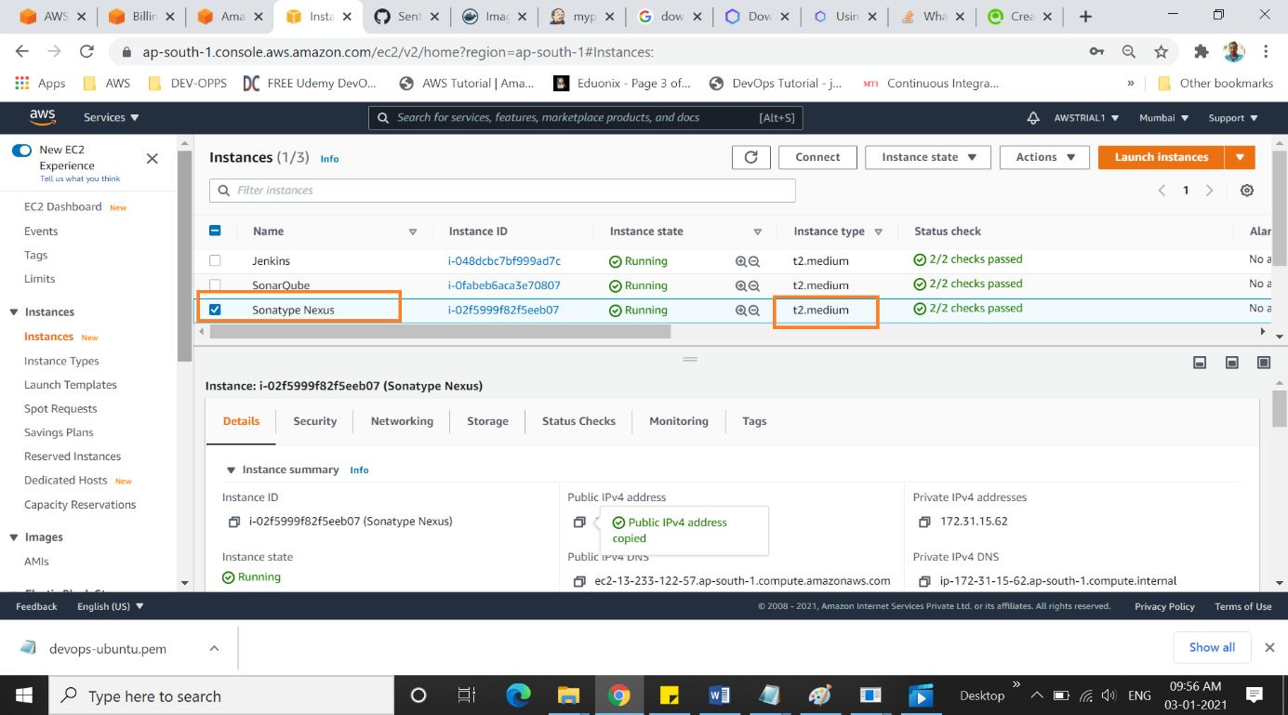

1. Install Java-1.8.0

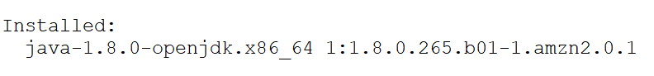

1. https://help.sonatype.com/repomanager3/download

cd /opt

# wget https://download.sonatype.com/nexus/3/latest-unix.tar.gz

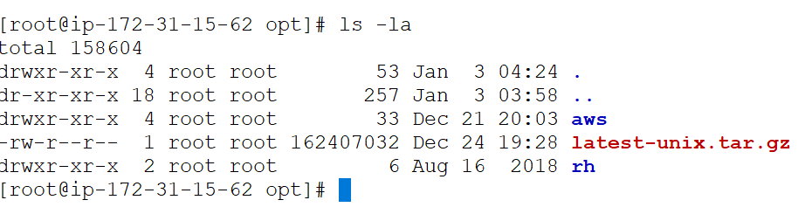

# tar -xvzf latest-unix.tar.gz (Unzip / untar)

# cd /opt/nexus-3.29.1-01/bin

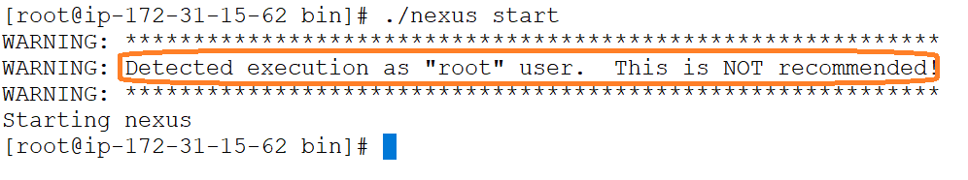

xxx.xxx.xxx.xxx: **8081 default port no for Nexus**

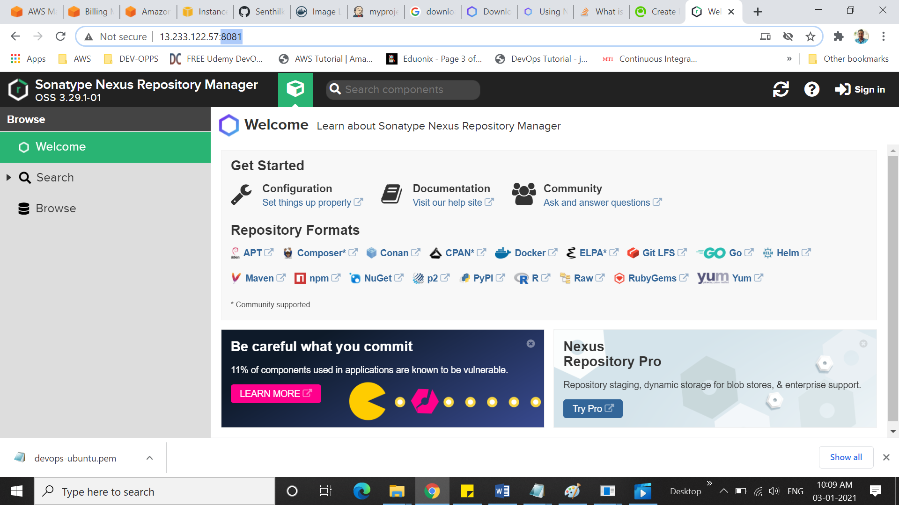

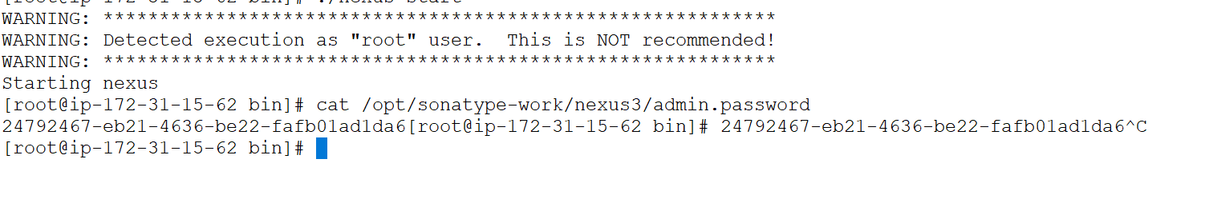

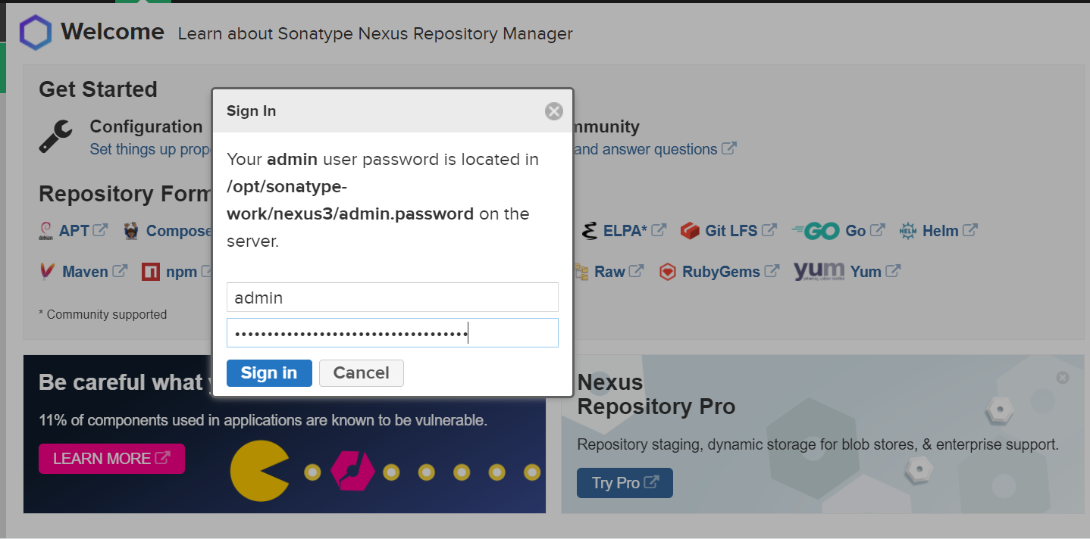

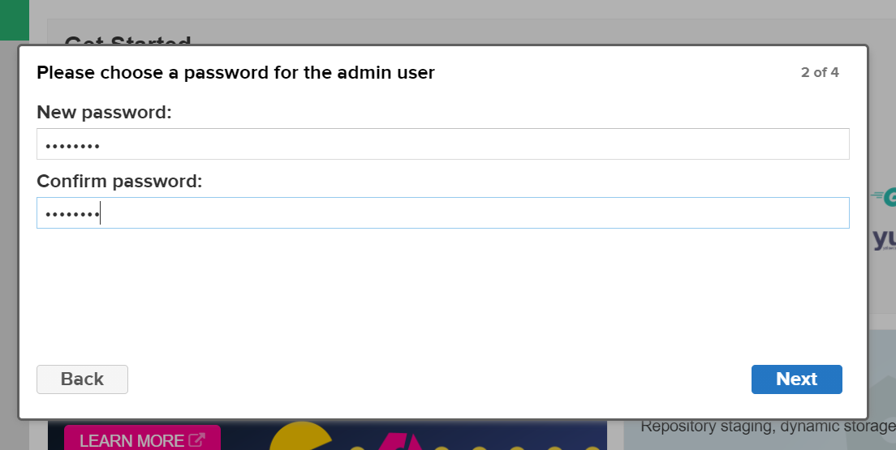

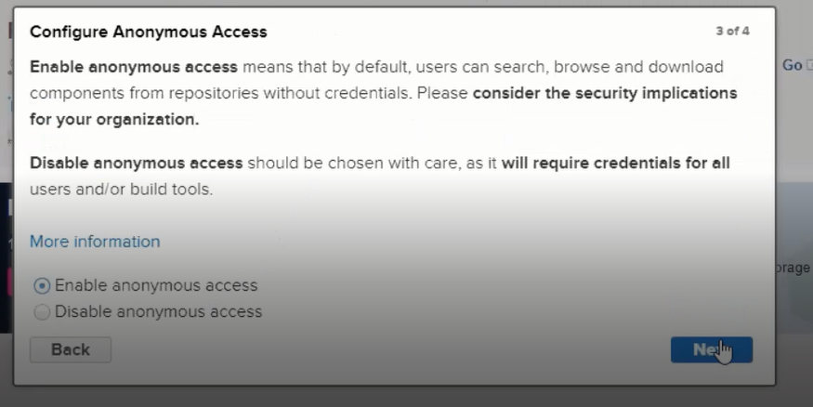

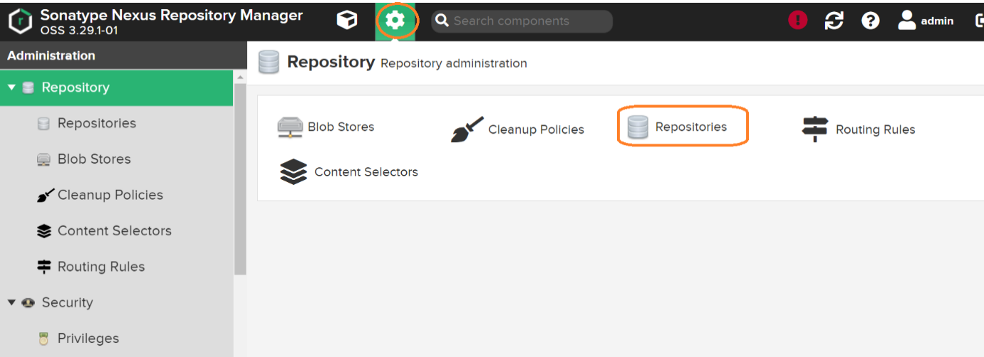

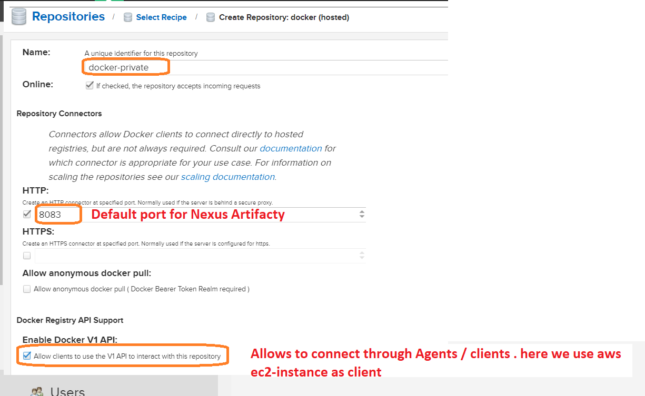

Docker-Private Artifactory Created

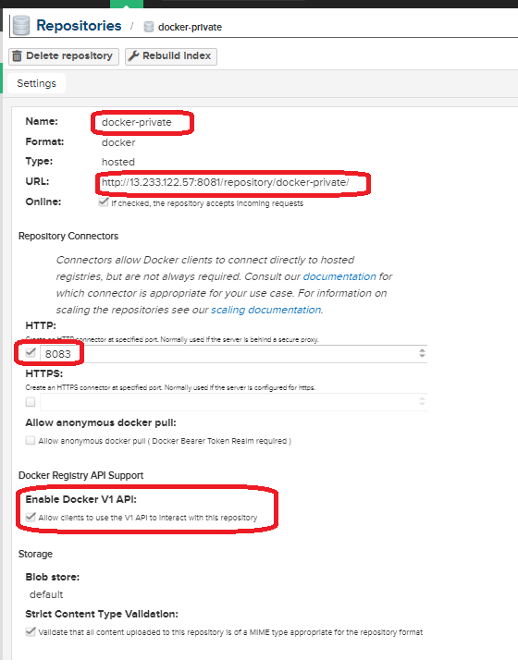

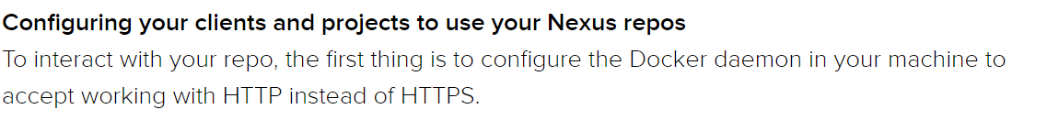

Need to install Docker in the Nexus Machine

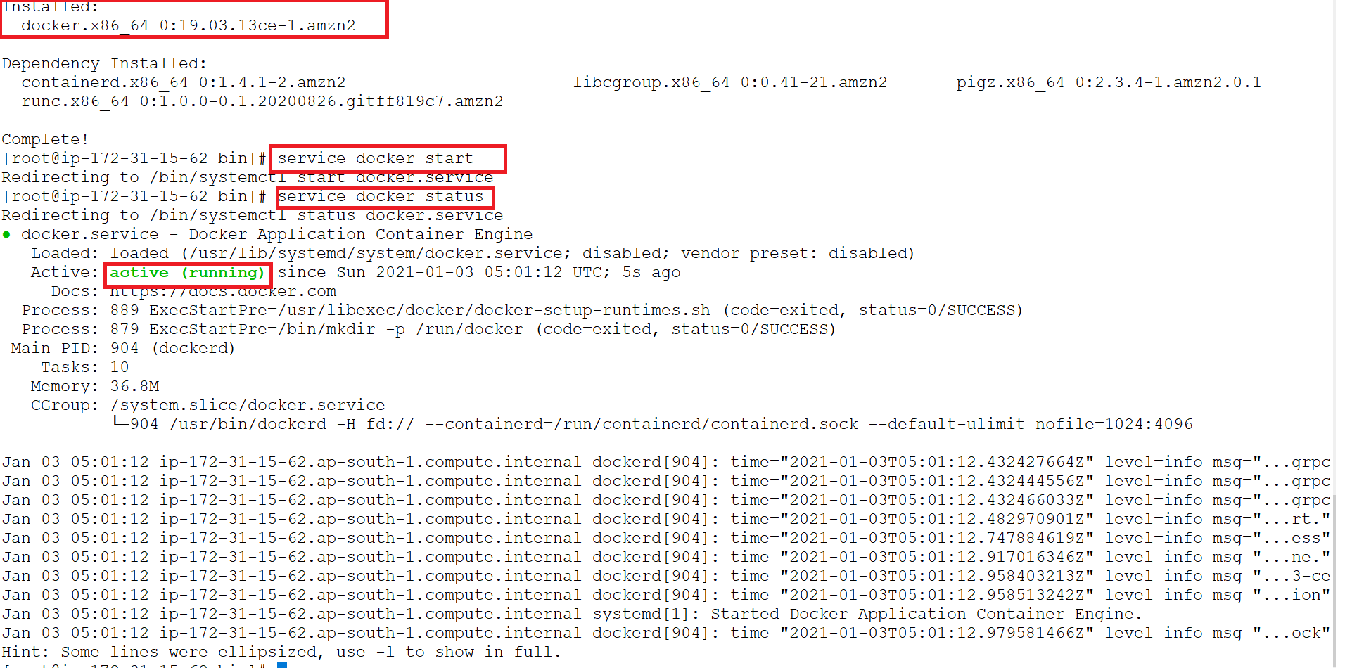



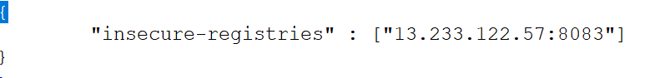

You have to restart the daemon after setting this (sudo systemctl restart docker).  
# sudo systemctl restart docker

**\*\*\*\* Now the same daemon file will be create into Container will be running.  
in this session we run the container as docker in Jenkins machine.**

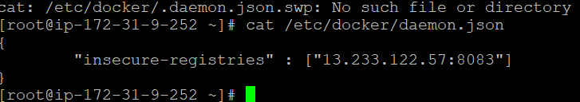

stage('Nexus Image Push'){

sh "docker login -u admin -p admin123 13.233.122.57:8083"

sh "docker tag sendocx/myweb:0.0.2 13.233.122.57:8083/sendocx:1.0.0"

sh 'docker push 13.233.122.57:8083/sendocx:1.0.0'

}

**Apply into jenkins PIPELINE**

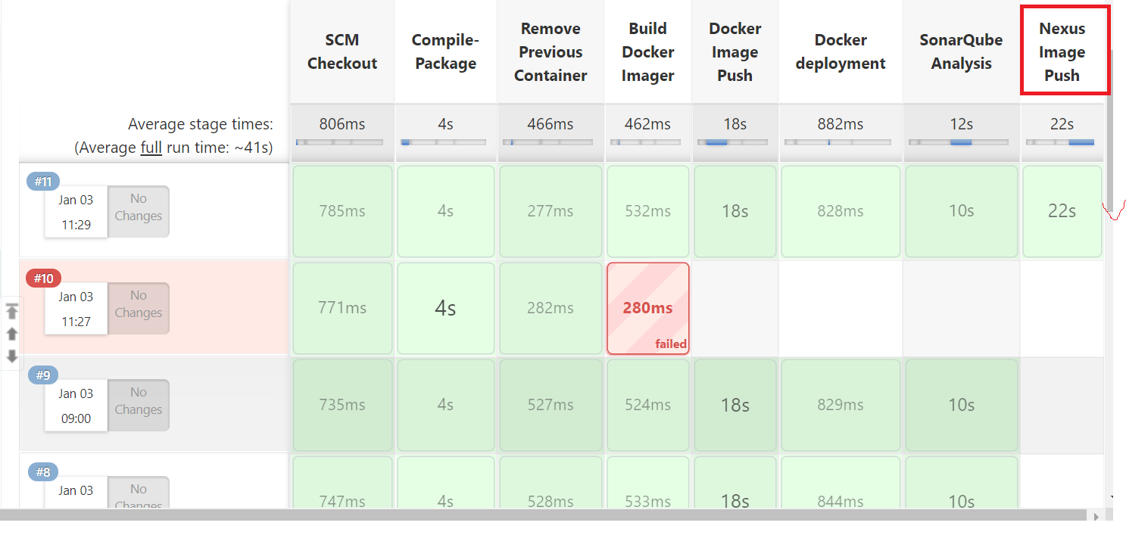

**Container created in Nexus repository**

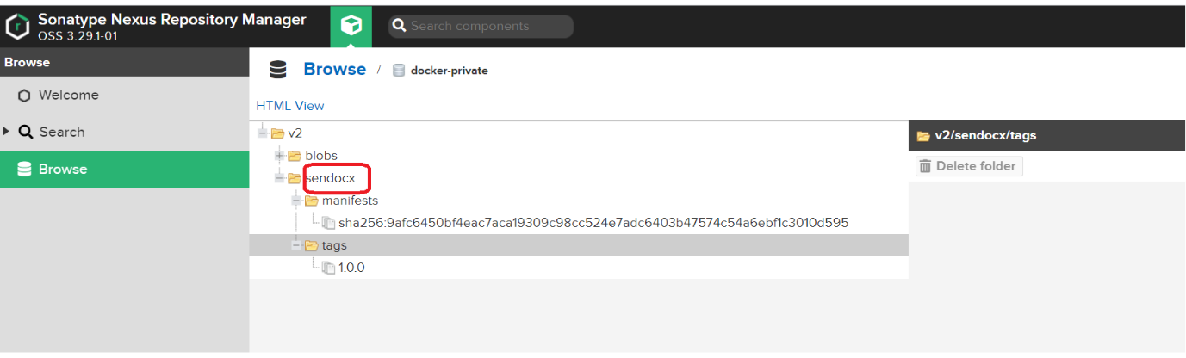

**7.Install & Configure** [**Prometheus**](https://github.com/prometheus)

**Now Monitor the Container and its Properties**

[**Prometheus**](https://github.com/prometheus)is an open-source systems monitoring and alerting toolkit .

We use [**Prometheus**](https://github.com/prometheus)as a docker container , installed in Nexus Machine.  
and **cadviser** as a communication agent.

**We using Nexus Machine to install and configure Promethrus.**

# docker run -it -d --name prom -v /etc/prometheus:/etc/prometheus -p 9090:9090 prom/prometheus

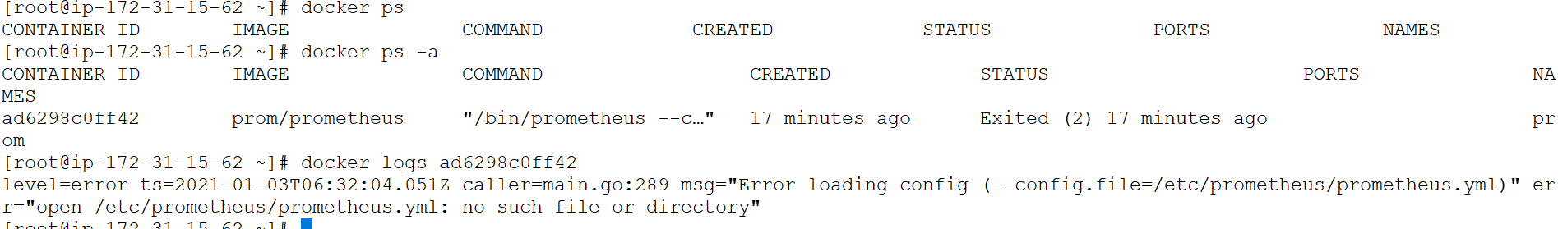

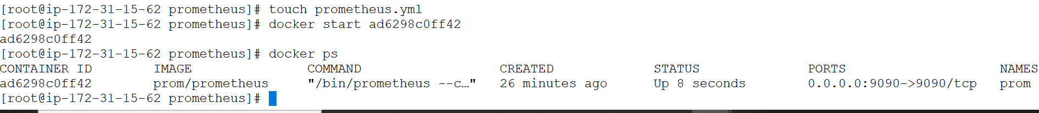

**Now Promethrus. Is Running.**

But prometheus.yml is empty. We need to configure the file

From <https://docs.docker.com/config/daemon/prometheus/>

Copy & Paste the full file into prometheus.yml

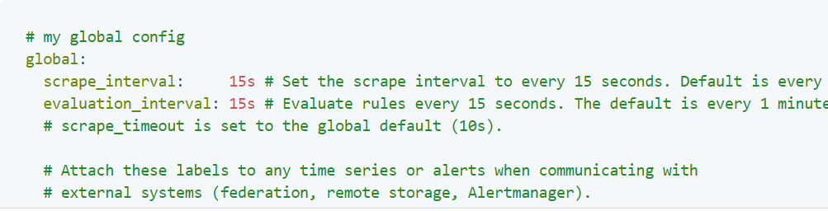



**Execute the Prometheus Applicatin from the Nexus Application Path.** (both are running in same machine).but the port is different

Default port for **Prometheus is 9090**

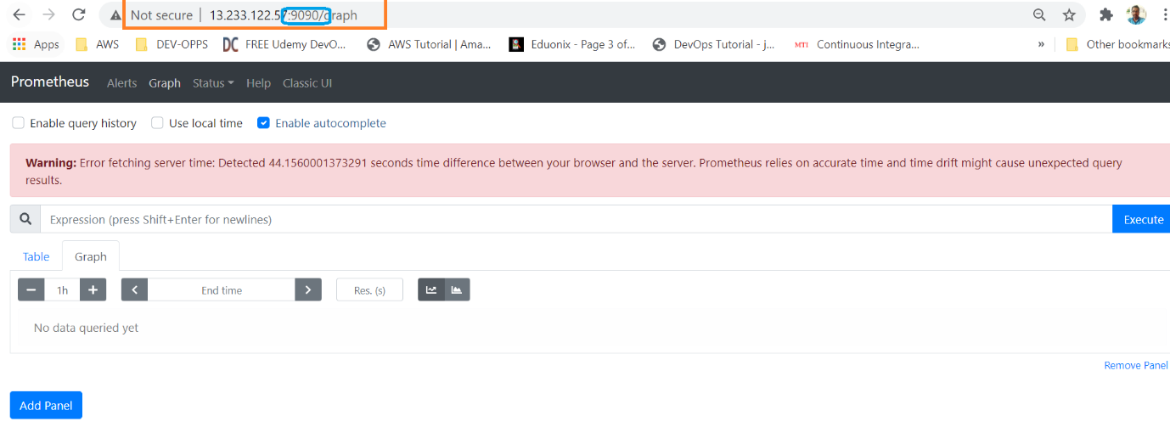

Prometheus need some agent to collect the data and execute. We use **cadvisor Prometheus** as the agent

The jenkins macine is used to configure the cadvisor, because the docker container is located in that machine.

# docker run -d --name cadvisor -p 8081:8080 -v /:/rootfs:ro -v /var/run:/var/run:rw -v /sys:/sys:ro -v /var/lib/docker/:/var/lib/docker:ro google/cadvisor

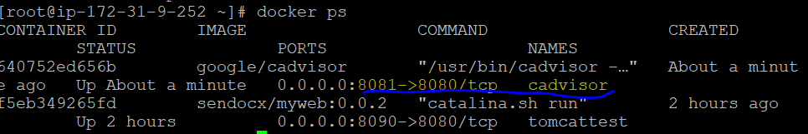

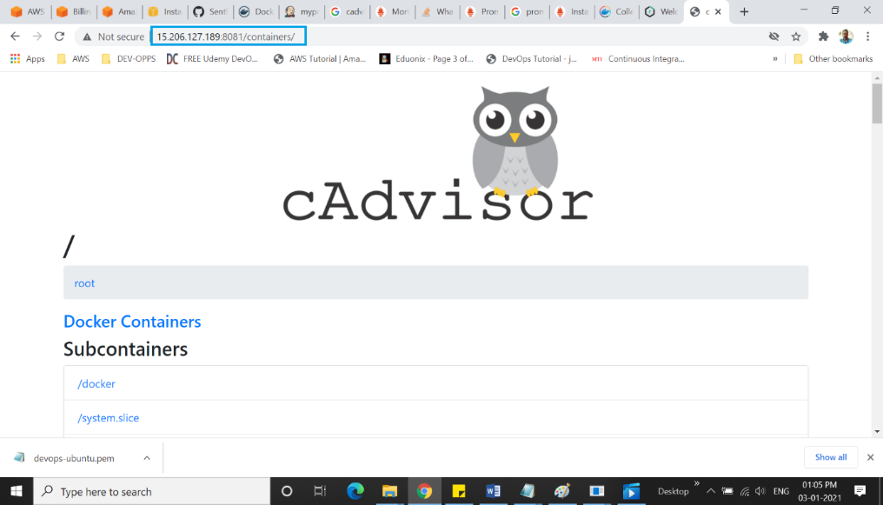

cadvisor is the communication agent for Prometheus.  
 But the machines are configured in different machines.

Cadvisor- http://15.206.127.189:8081/containers/

Prometheus. <http://13.233.122.57:9090/graph>

Now to integrate this two to execute the result.

* To instruct the Prometheus, where the cadvisor is running
* Edit prometheus.yml
* Replace the local host ip as cadvisors ip and port

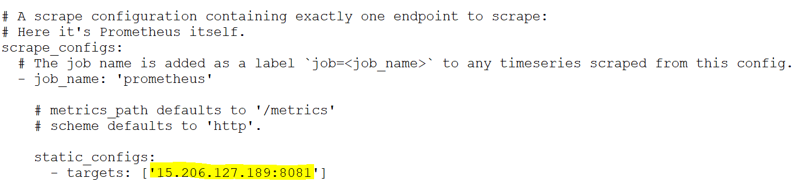

* Restart the docker

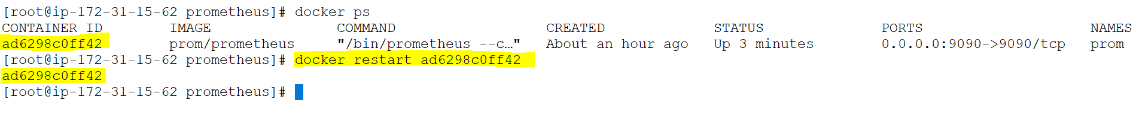

Execute the “ container_memory_usage_bytes{name="tomcattest"} “ in the Prometheus machine

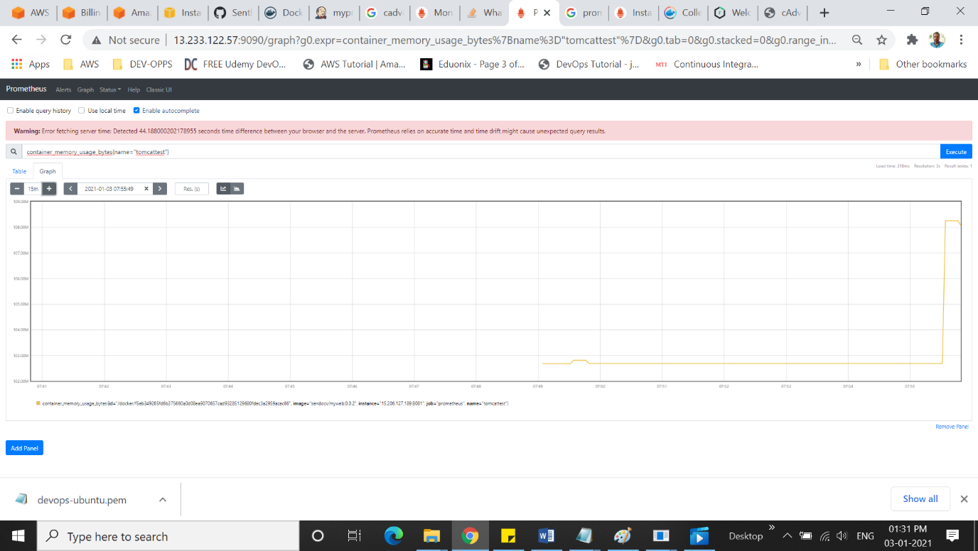

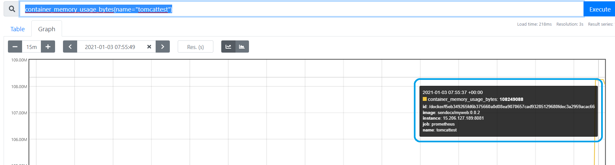

**Now Integrate GIT and Jenkins.**

**Open Github**

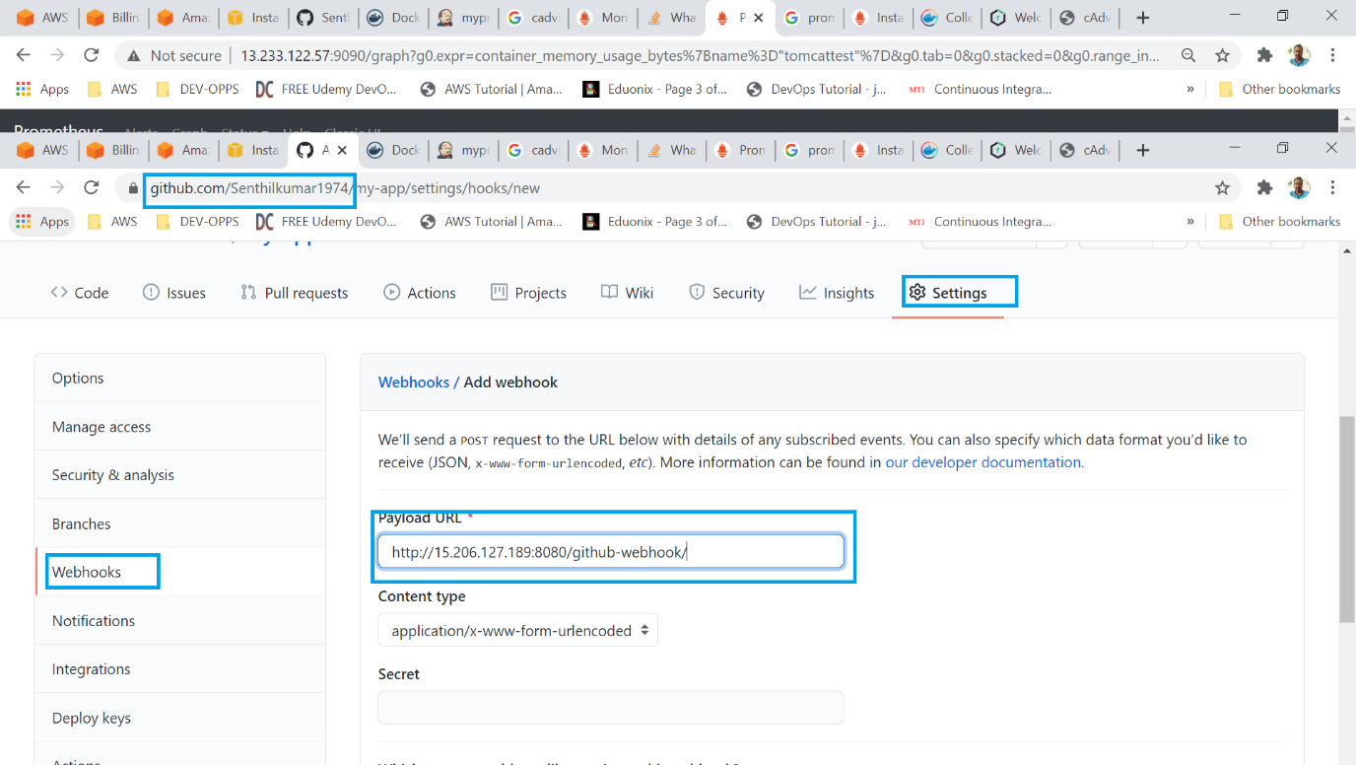

**Changes in Jenkins**

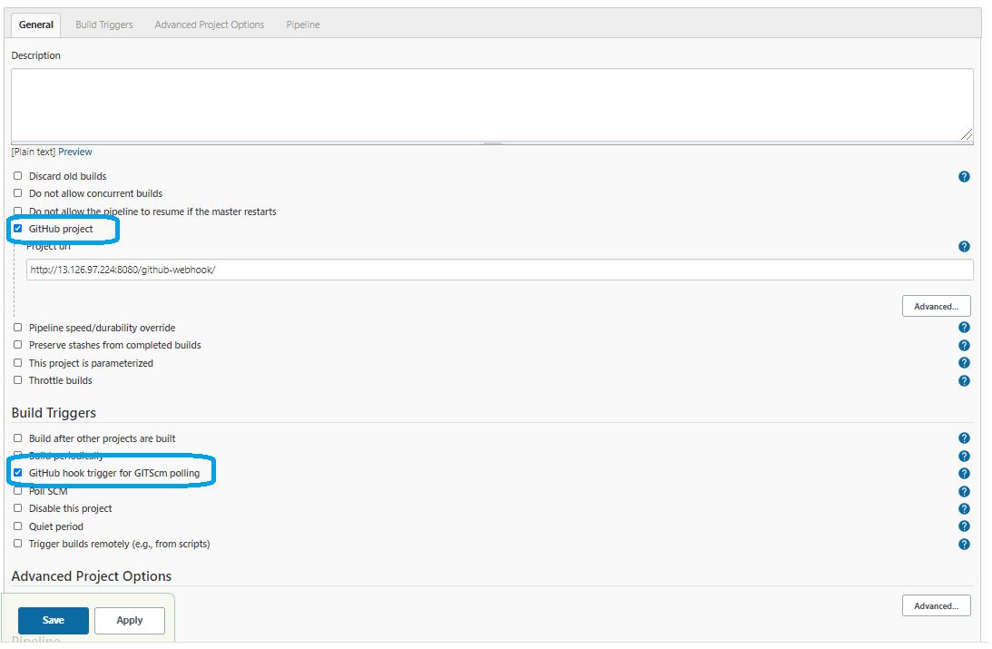

**## SonarQube –added into Jenkins PipeLine**

**Elastic search** is a search engine based on the Lucene library. It provides a distributed, multitenant-capable full-**text** search engine with an HTTP web interface and schema-free JSON documents. Elastic search is developed in Java.

**# # Does SonarQube need database?**

Before you **can** get **SonarQube** up and running, there are a few prerequisites. You'll **need** to **have** Java installed where you **want** to run **SonarQube**, at least version 6, as well as a **database**. ... But you **can** use any one of the supported **databases**: Oracle, Postgres, SQL Server, and of course MySQL

**## Difference between configure system and global tool configuration in Jenkins?**

What is **global tool configuration** in Jenkins?

In this section, we will **configure** various **tools** that we need to utilize at the time of creating a build job, for example, Java, Ant, Maven, and so on. We can add multiple JDK and while creating a Build Job, we can specify which JDK we want to utilize for that build job execution. ...

What is configure system in Jenkins?

**Configure System**. ... The **configure system** page is a critical **configuration** part. This screen represents a variety of sections, each correlating to a different **configuration** area from generic **Jenkins settings**, global environment variables, and most installed plugins are configured on this page.

|  |  |  |
| --- | --- | --- |
| **Sno** | **Application** | **Default Port** |
| 1. | **Jenkins** | 8080 |
| 2. | **Tomcat** | 8090 |
| 3. | **Amazon – RDS (MySQL)** | 3306 |
| 4. | **SonarQube** | 9000 |
| 5. | **Sonatype Nexus** | 8081 |
| 6. | **Docker Private for Nexus** | 8083 |
| 7. | [**Prometheus**](https://github.com/prometheus) | 9090 |
| 8 | **Cadviser** | 8081 |